

**PICTURE OF ORAL HEALTH 2017**

**DENTAL CARIES IN 5 YEAR OLDS (2015/2016)**

|  |
| --- |
| Summary  Background  Decay in Wales  Average decayed missing and filled teeth (dmft) in Wales  Prevalence of decay in Wales  Decay experience of those with decay affected teeth  Caries by quintile of deprivation  Decay in Local Health Boards  Average decayed missing and filled teeth (dmft) in LHBs  Prevalence of decay in LHBs  Decay experience of those with decay affected teeth  Decay in Unitary Authorities  Designed to Smile Impact  Schools Involved in Designed to Smile Programme  Appendices  Appendix 1 – %dmft>0 by Unitary Authority, 2007/08 to 2015/16  Appendix 2 Key Dental Caries Variables from the Survey of 5 year olds 2015/16  Appendix 3 Key Dental Caries Variables from the Survey of 5 year olds 2014/15  Appendix 4 Key Dental Caries Variables from the Survey of 5 year olds 2011/12  Appendix 5 Key Dental Caries Variables from the Survey of 5 year olds 2007/08  Appendix 6 Interpretation of historical survey data |

**Authors**

Maria Morgan, Senior Lecturer, Welsh Oral Health Information Unit, Cardiff University.

Nigel Monaghan, Honorary Senior Lecturer, Cardiff University.

<http://www.cardiff.ac.uk/dentl/research/themes/appliedclinicalresearch/epidemiology/oralhealth/index.html>

©Cardiff University, June 2017

**Summary**

Caries in school year 1 children (aged 5-6) continues to fall across Wales. Only Cwm Taf LHB has not seen a statistically and clinically significant reduction in caries experience amongst this age group.

In 2007/08 14 out of a class of 30 children would have decay experience, and these 14 children would have an average of 4.2 teeth affected. BY 2015/16 this had fallen to 10 children out of a class of 30, and these 10 would have an average of 3.6 decayed teeth.

Dental disease levels in children in Wales continue to improve across all social groups. In absolute terms the most deprived quintile have seen the largest reduction in decay prevalence (by 15%) and mean dmft score (by 0.6). There is no evidence of widening inequalities here.

The fact that children attending schools in the most deprived quintile are those seeing the greatest improvements in decay experience is likely to be due to the impact of the Designed to Smile programme. The data from the four surveys also demonstrates that Designed to Smile is targeting children with higher levels of decay.

Although there have been great improvements in caries in school year 1 children over the last 9 years, there is plenty of scope for further improvement for the 1/3rd of children still experiencing tooth decay.

**Background**

These pages present data from a dental survey of school year 1 children (approximately 5-years of age) undertaken in Wales between September 2015 and April 2016, as a part of the NHS dental survey programme.

This is the 4th survey using positive parental (opt-in) consent. The data is comparable with surveys undertaken since 2007/08.

**Decay in Wales**

**Average decayed missing and filled teeth (dmft)**

The sum of decayed, missing and filled teeth is a measure of the decay experience of the average child. It is therefore the burden of disease which theoretically could have been prevented and thus key data for evaluation of efforts to prevent decay.

Figure 1 shows the trend in the mean number of decayed, missing and filled teeth per child in Wales. Between 2007/08 and 2015/16 there has been a reduction in dmft from 1.98 to 1.22. This represents a 38% reduction in mean dmft scores in 9 years.

Figure 1 Mean dmft in school year 1 children in Wales 2007/08 – 2015/16

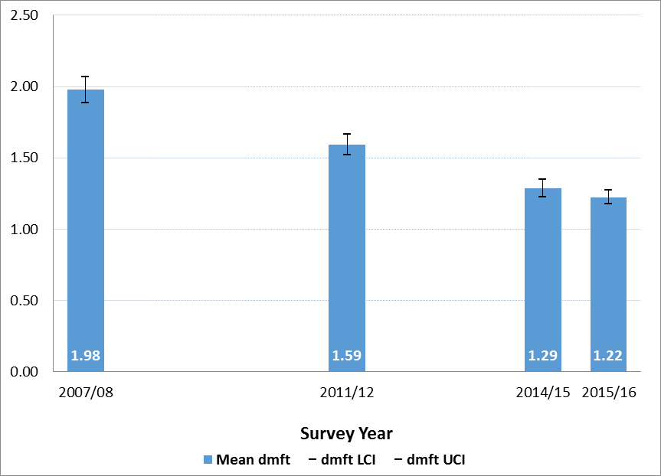

*See Appendices for data*

**Prevalence of decay in Wales**

Not all of the children examined had decay. Figure 2 shows a reduction in the proportion of children with decay between 2007/08 (47.6%) and 2015/16 (34.2%). This represents continuing improvement of the proportion of children who have no obvious decay experience by age 5. Thus in 2015/16 in a class of 30 children 20 will have no decay experience. This compares with 16 in a class of 30 children decay free in 2007/08.

Figure 2 Percentage of children in Wales with caries (%dmft>0) 2007/08 – 2017/16

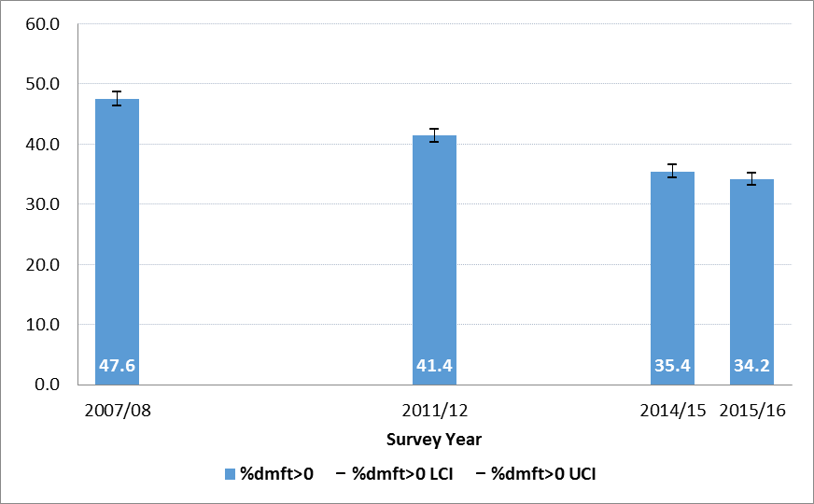

*See Appendices for data*

**Decay experience of those with decay affected teeth (mean dmft where dmft>0)**

Data on mean decay scores of those children who have at least 1 decayed, missing or filled tooth illustrate the stark differences between children with decay and those without (Figure 3). The continuing reduction from 4.16 in 2007/08 to 3.58 in 2015/16 is statistically and clinically significant.

Figure 3 Mean dmft of children in Wales with decay experience (mean dmft where dmft>0) 2007/08 – 2015/16

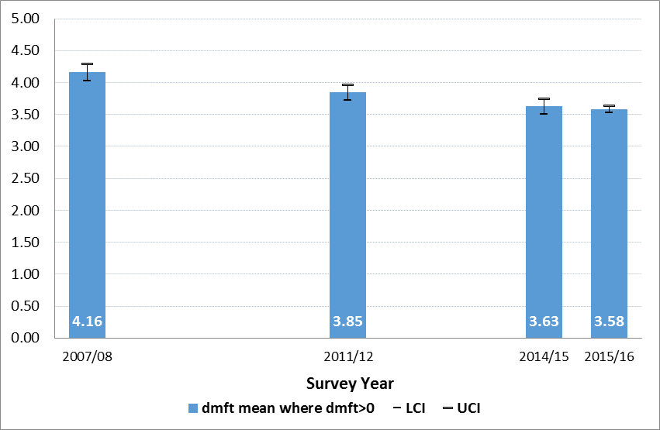

*See Appendices for data*

**Caries by quintile of deprivation**

Figure 4 Mean number of decayed teeth (dmft) in Welsh children by quintile of deprivation, 2007/08 – 2015/16

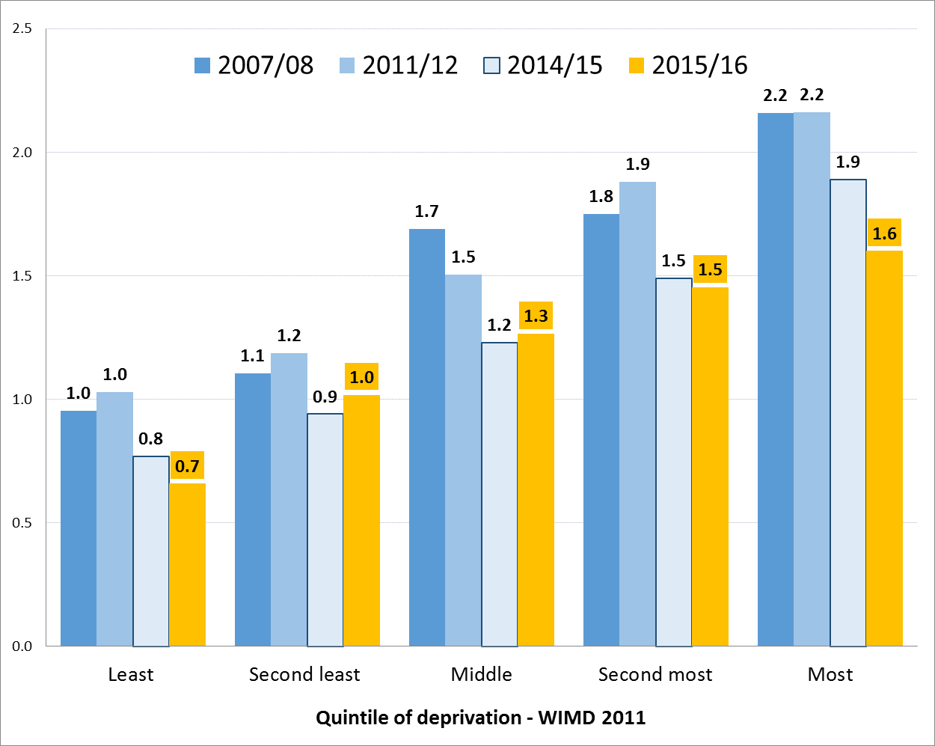

Figures 4 and 5 illustrate the relationship between decay experience and the Welsh Index of Multiple Deprivation (WIMD). Mean dmft and the %dmft>0 for all quintiles of deprivation have fallen in 2015/16 when compared with values for 2007/08. The largest improvements are in the most deprived quintile. These improvements are impressive given that in times of economic downturn decay would be expected to rise or show little improvement.

Figure 5 % of children in Wales with decay by Welsh Index of Multiple Deprivation (%dmft>0), 2007/08 – 2015/16

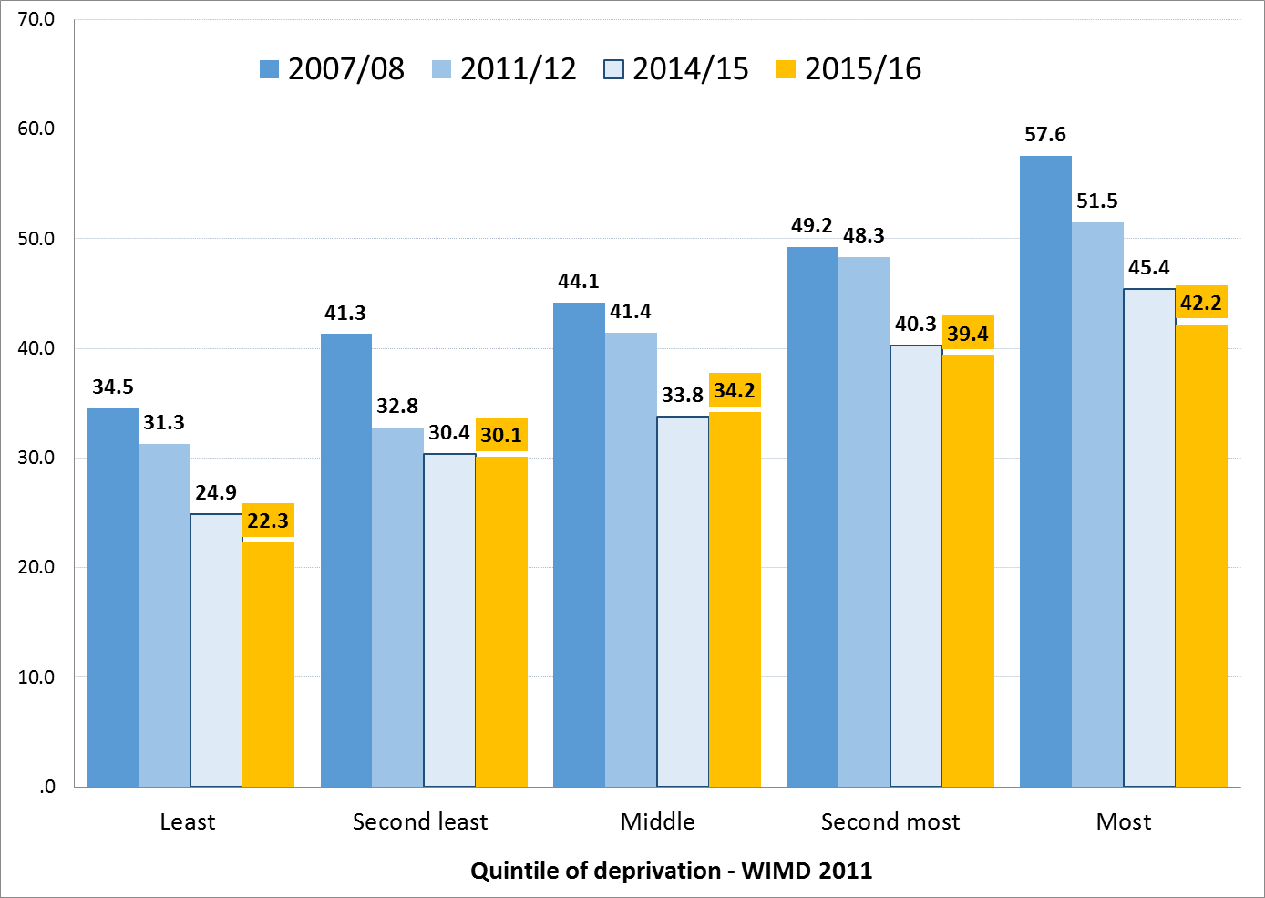

**Decay in Local Health Boards**

**Average decayed missing and filled teeth (dmft) in LHBs**

Local Health Board (LHB) mean dmft scores for 2007/08 until 2015/16 are presented in Figure 6 and have shown statistically significant reductions over 9 years in all LHBs except Cwm Taf. The mean dmft in 2015/16 ranged from 0.87 in Powys to 1.65 in Cwm Taf.

Figure 6 Mean dmft per 5 year old by LHB, 2007/08 – 2015/16

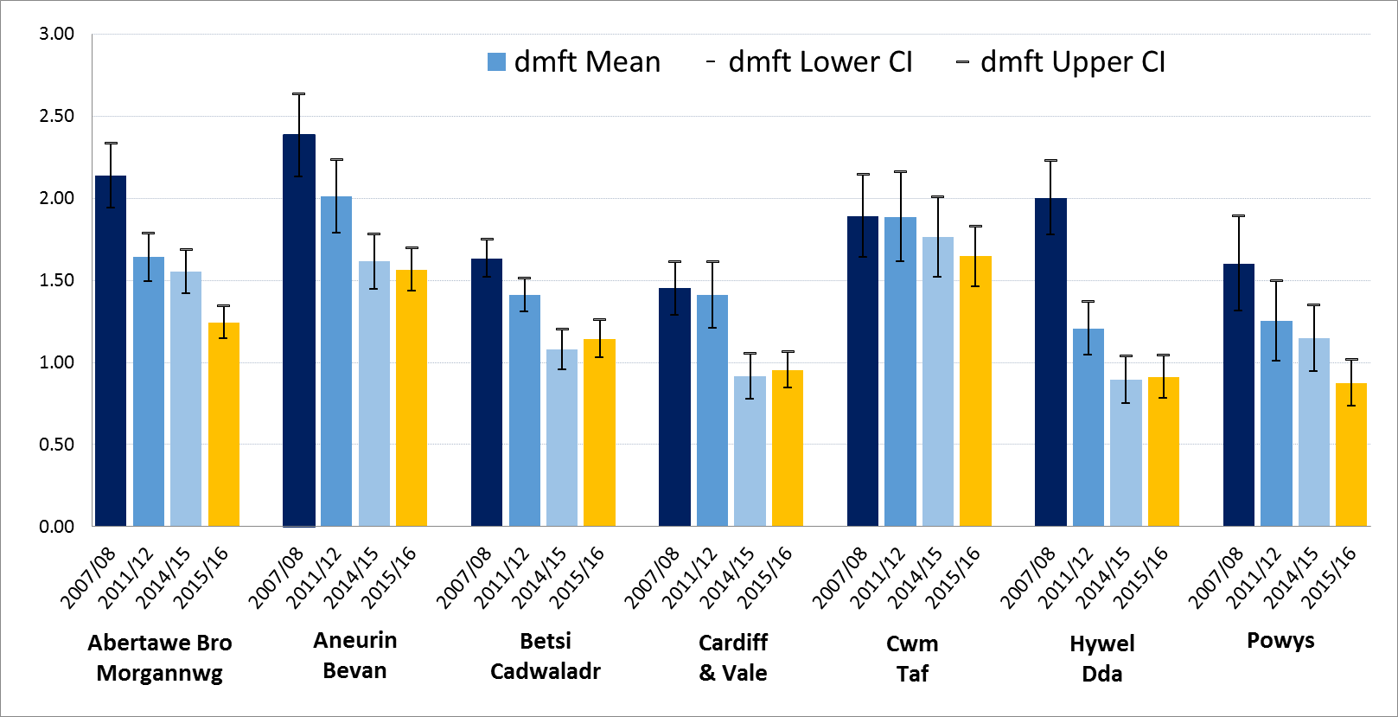

*See Appendices for data*

**Prevalence of decay in LHBs**

Figure 7 Percentage with caries (%dmft>0) among 5 year olds by LHB, 2007/08 – 2015/16

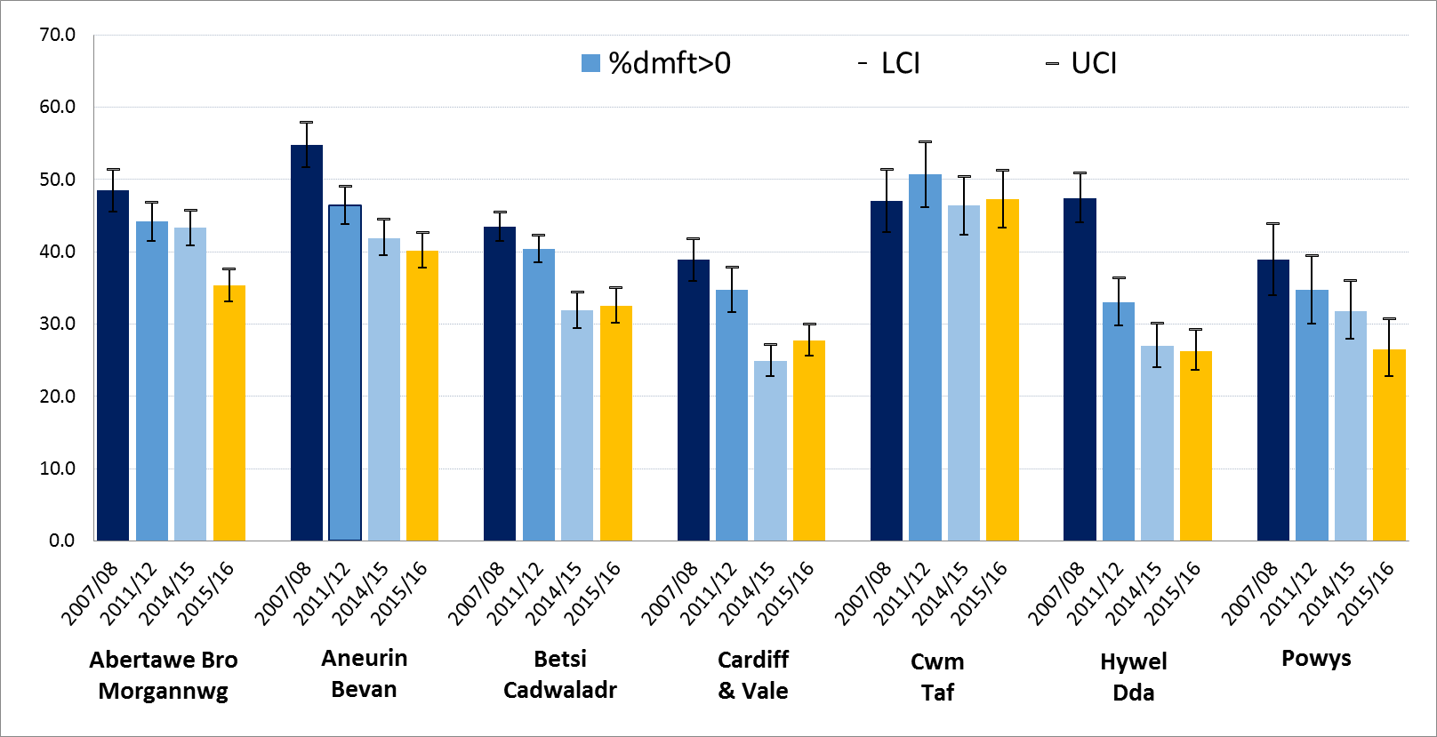

*See Appendices for data*

Figure 7 illustrates the proportion of children with at least 1 decayed tooth (%dmft>0) by LHB between 2007/08 and 2015/16. There have been statistically significant reductions in this index for all LHBs, except Cwm Taf. In 2015/16 the percentage of children with caries experience ranged from 26.3% in Hywel Dda to 47.3% in Cwm Taf.

**LHB - Decay experience of those with decay affected teeth (mean dmft where dmft>0)**

Figure 8 Mean dmft of those with decay experience (mean dmft where dmft>0) by LHB, 2007/08 – 2015/16

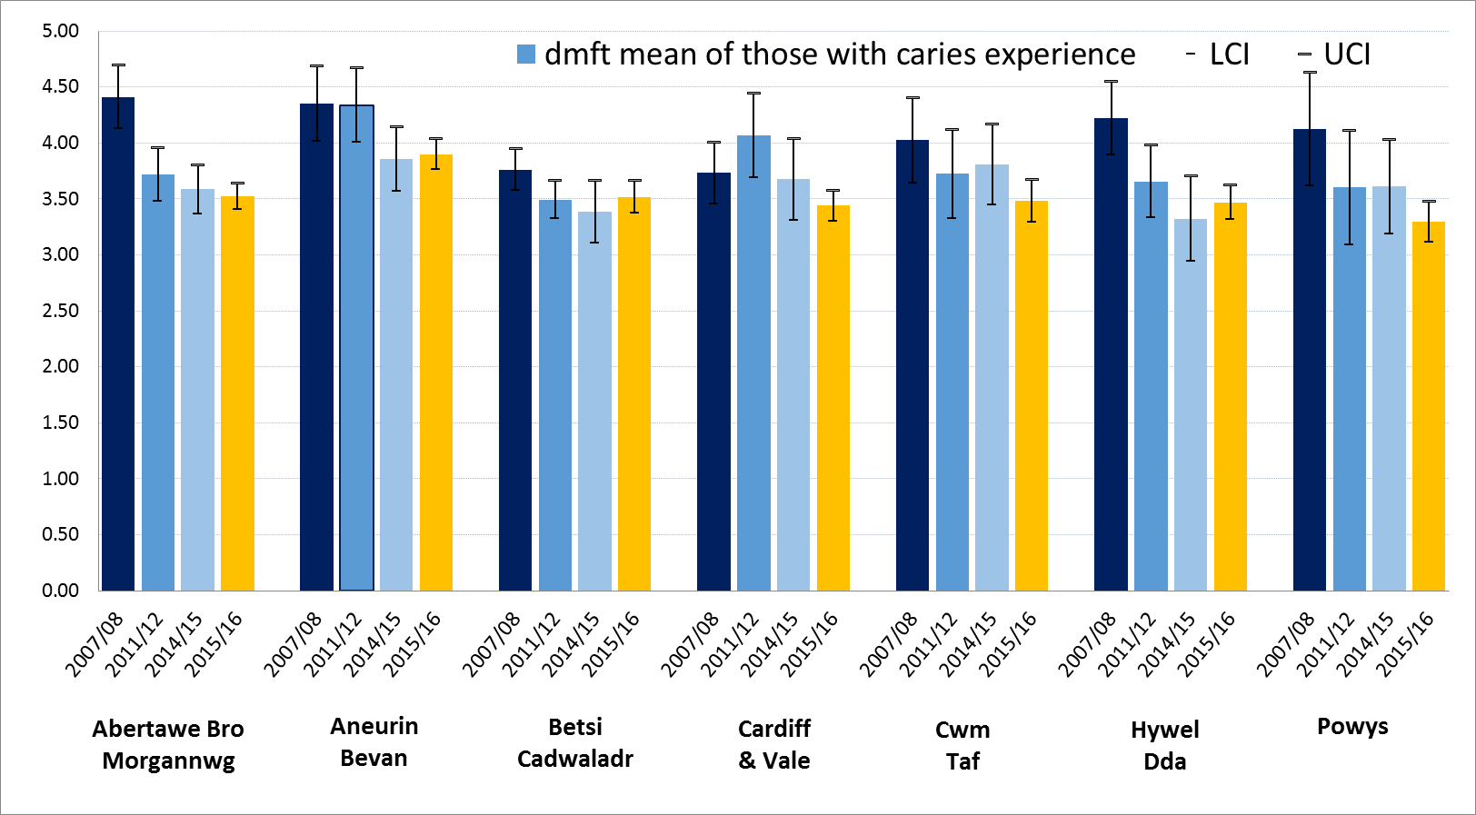*See Appendices for data*

Figure 8 presents the average number (from 1 to 20) of decayed teeth for children with some decay, i.e. mean dmft of those with dmft. In 2015/16 this ranged from 3.29 in Powys to 3.90 in Aneurin Bevan. The range in 2007/08 was from 3.73 in Cardiff and Vale to 4.41 in Abertawe Bro Morgannwg. The gradual reduction in this indicator is a sign of improved caries experience across the full spectrum.

**Decay in Unitary Authorities**

As Unitary Authorities have smaller populations than LHBs the sample size for the survey is smaller and findings from the survey are therefore less likely to demonstrate statistically significant changes.

The %dmft>0 by Unitary Authority is shown in Appendix 1 for each LHB in Wales for 2007/08 to 2015/16. Statistically significance reductions in decay have been seen in 11 of the 22 Unitary Authorities.

**Wider UK Data**

At the time of drafting this report wider UK data for mean dmft for 2014/2015 is not available. In due course access to this data should be available via links on the [British Association for the Study of Community Dentistry website.](http://www.bascd.org/oral-health-surveys)

Wider UK data is reported alongside Welsh data in publications in the Community Dental Health Journal. The [latest paper](http://www.cdhjournal.org/article/575-the-caries-experience-of-5-year-old-children-in-scotland-in-2013-2014-and-in-england-and-wales-in-2014-2015-reports-of-cross-sectional-dental-surveys-using-bascd-criteria) reviews data from 2014/15 across Great Britain (*The caries experience of 5 year-old children in Scotland in 2013-2014, and in England and Wales in 2014-2015. Reports of cross-sectional dental surveys using BASCD criteria*).

Scotland publishes findings from its [dental inspection](http://ndip.scottishdental.org/ndip-reports/) programme.

England publishes findings from its dental surveys on the [English Dental Observatory](http://www.nwph.net/dentalhealth/) website.

**Designed to Smile Impact**

Designed to Smile is the National Oral Health Programme for Wales. This is a targeted oral health promotion programme which is focussed on preventing dental decay in children in pre-school and primary school settings. Work to roll the programme out across the whole of Wales commenced in 2010. Further information is available from the [Welsh Oral Health Information Unit](http://www.cardiff.ac.uk/dentl/research/themes/appliedclinicalresearch/epidemiology/oralhealth/index.html).

Over the last 3 surveys samples included 5 year old children from schools involved in the initial Designed to Smile pilot and from schools that are now being included in the Designed to Smile programme as it is rolled out. It also surveyed children who are not taking part in Designed to Smile. These surveys were not specifically designed to evaluate Designed to Smile, however D2S should impact on these indicators because of the scale of the D2S programme.

**Schools Involved in the Designed to Smile Programme**

Tables 1 and 2 illustrate the proportion of schools and children which are now participating (or not) in Designed to Smile which were randomly sampled in the surveys between 2007/08 and 2015/16.

**Table 1 Number of schools surveyed, by participation in D2S, 2007/08 – 2015/16**



**Table 2 Number of children examined, by survey year and participation in D2S**



Mean dmft in schools selected for inclusion in the Designed to Smile programme is greater than for the schools which have not been involved in the programme (Figure 9). Similarly, there is a larger proportion of children with decay experience (%dmft>0) attending schools now participating in Designed to Smile (Figure 10). This confirms that the programme is being targeted at schools with greater disease experience.

Since 2008, mean dmft has reduced in all schools. The reduction in mean dmft is slightly greater in Designed to Smile Schools (Figure 9). A similar improvement pattern is seen in the proportion of children with experience of decay (%dmft>0, Figure 10).

Figure 9 Mean dmft for children attending primary schools, by participation in Designed to Smile, 2007/08 – 2015/16

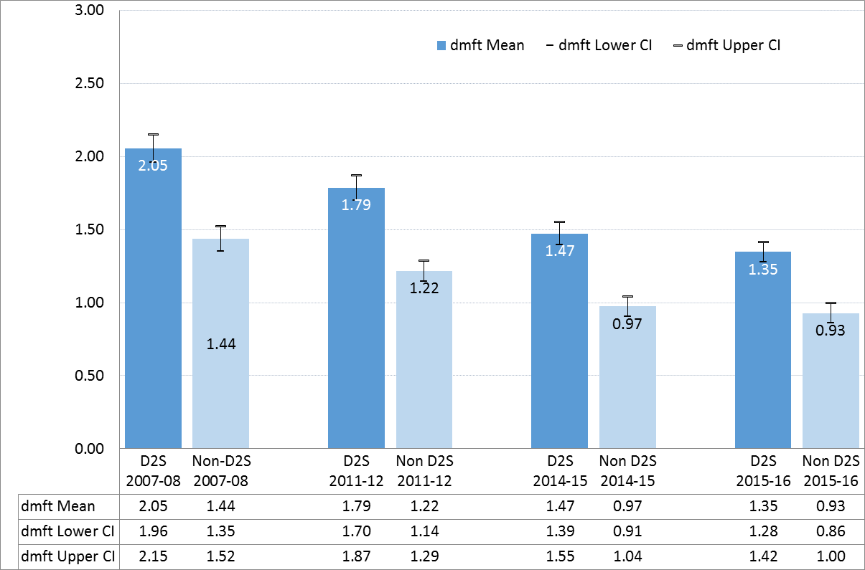

Figure 10 % dmft>0 for children attending primary schools, by participation in Designed to Smile, 2007/08 – 2015/16

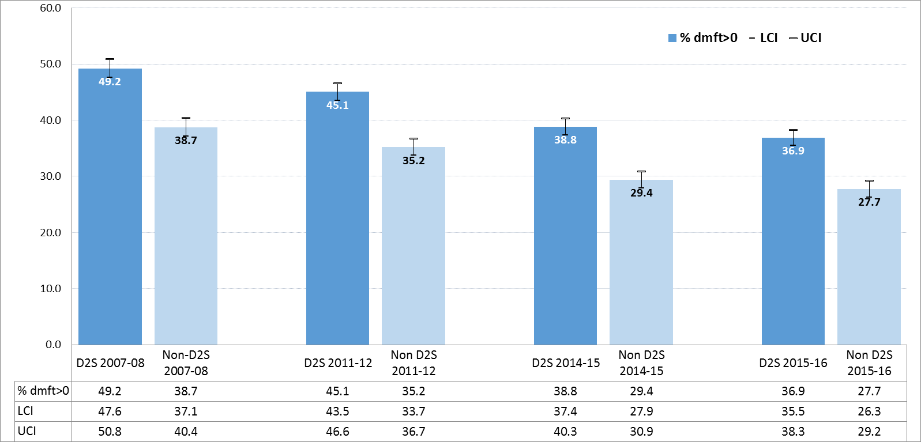

**Appendix 1 – %dmft>0 by Unitary Authority, 2007/08 to 2015/16**

Figure 11 ABMU – %dmft>0 by Unitary Authority, 2007/08 to 2015/16

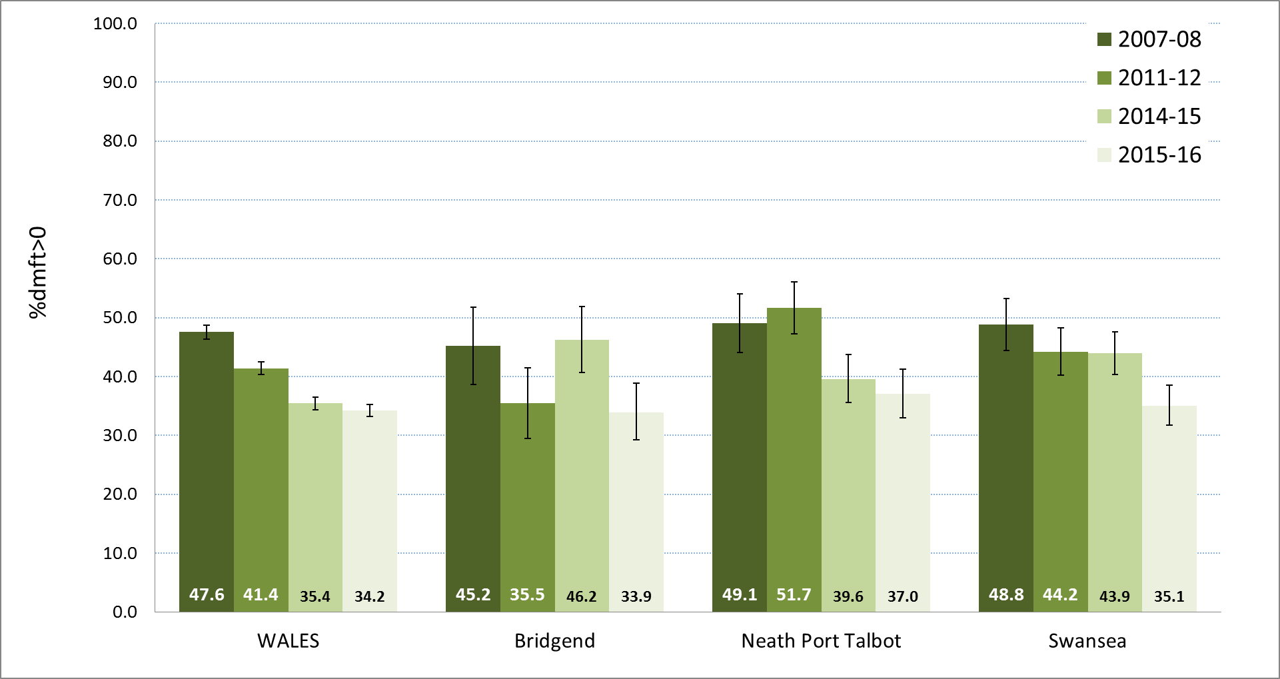

Figure 12 Aneurin Bevan – %dmft>0 by Unitary Authority, 2007/08 to 2015/16

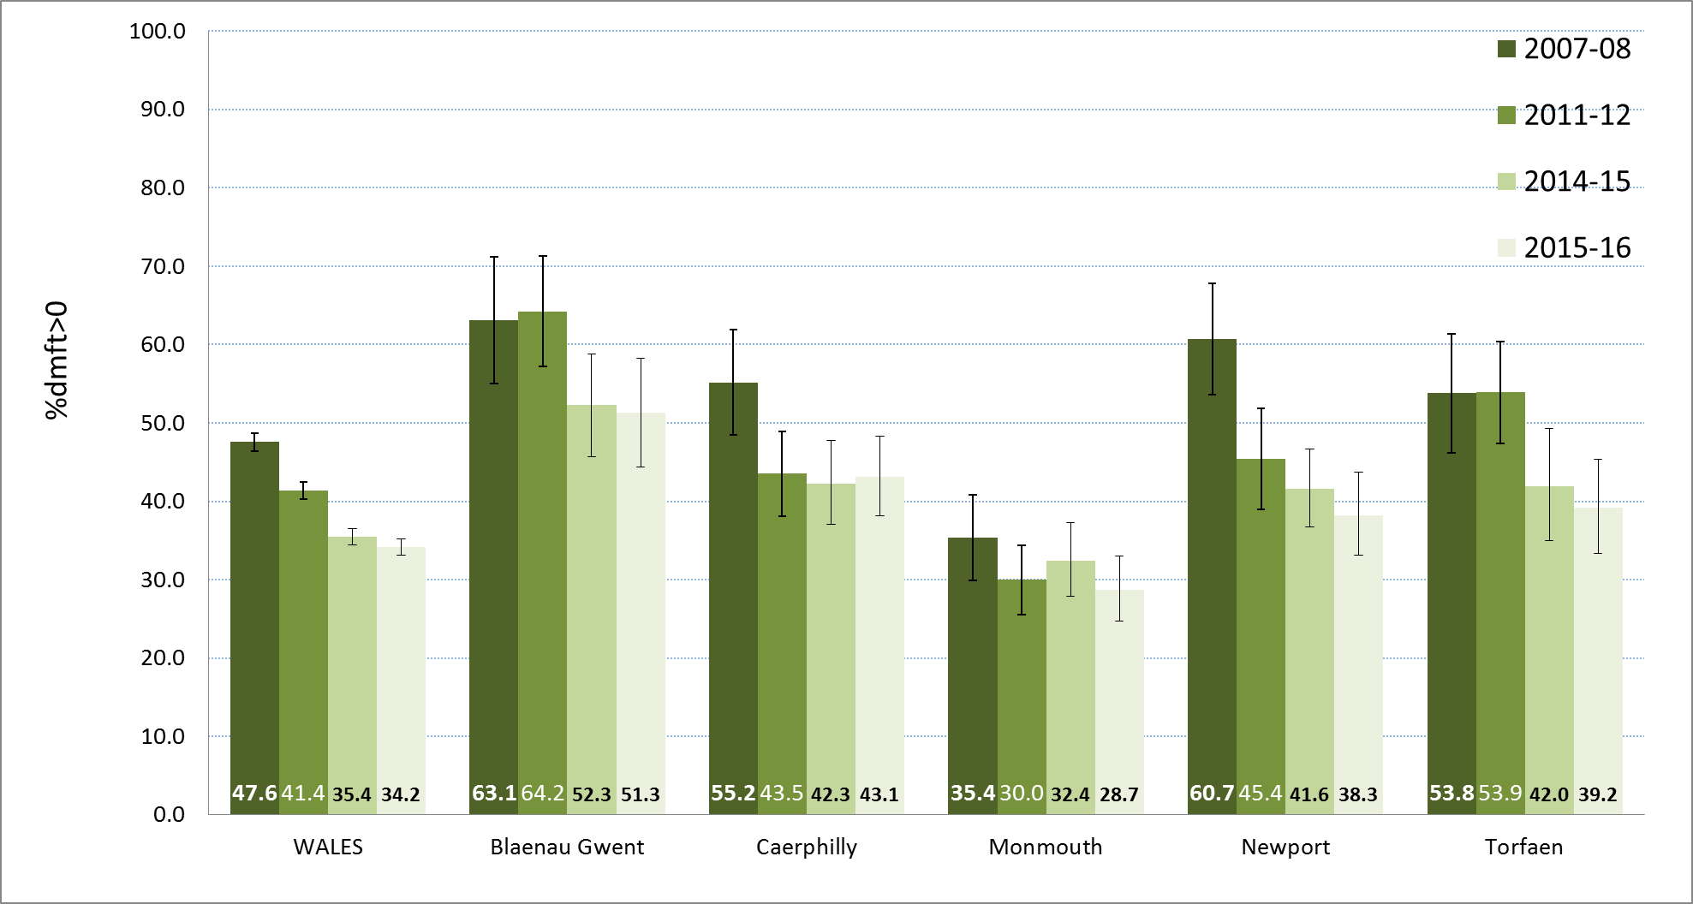

Figure 13 Betsi Cadwaladr – %dmft>0 by Unitary Authority, 2007/08 to 2015/16

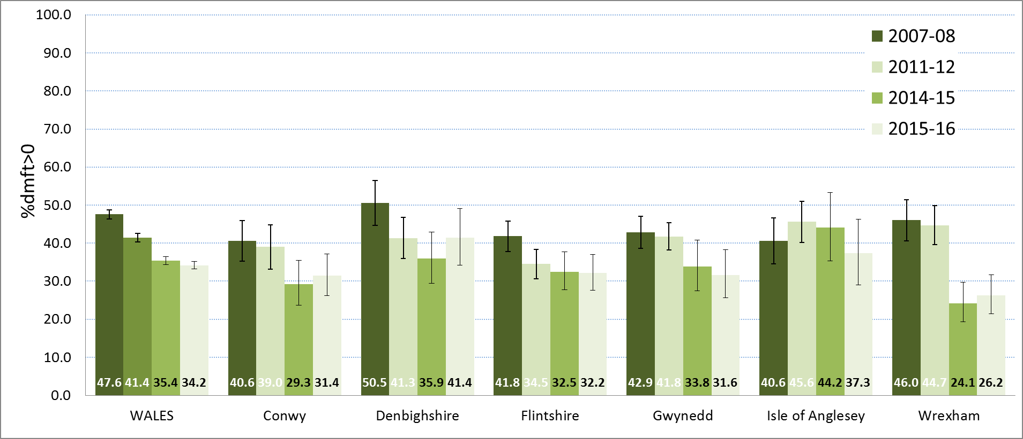

Figure 14 Cardiff and Vale – %dmft>0 by Unitary Authority, 2007/08 to 2015/16

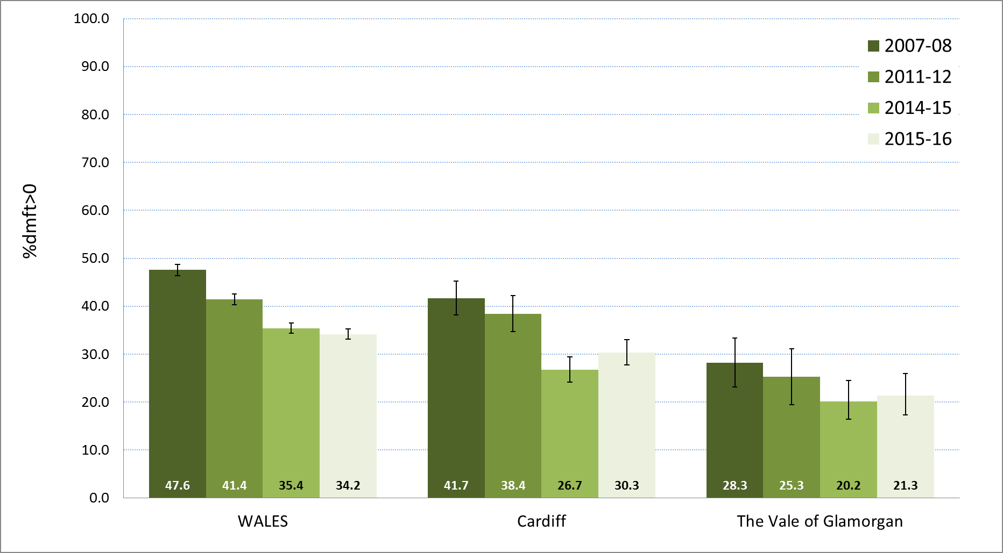

Figure 15 Cwm Taf – %dmft>0 by Unitary Authority, 2007/08 to 2015/16

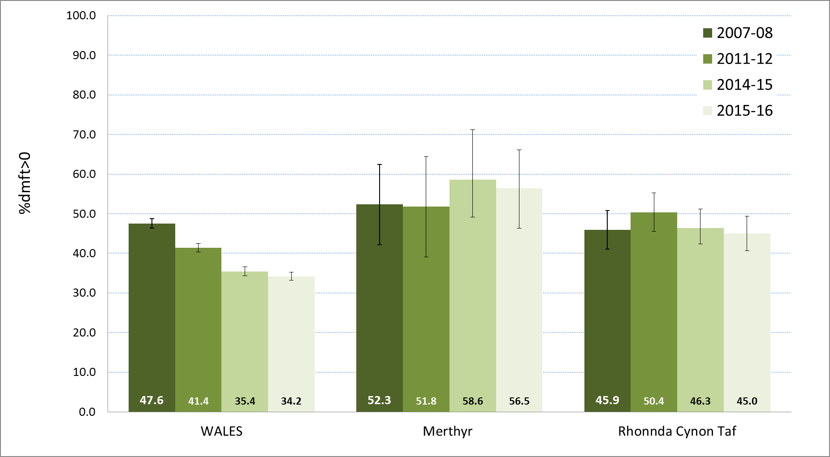

Figure 16 Hywel Dda – %dmft>0 by Unitary Authority, 2007/08 to 2015/16

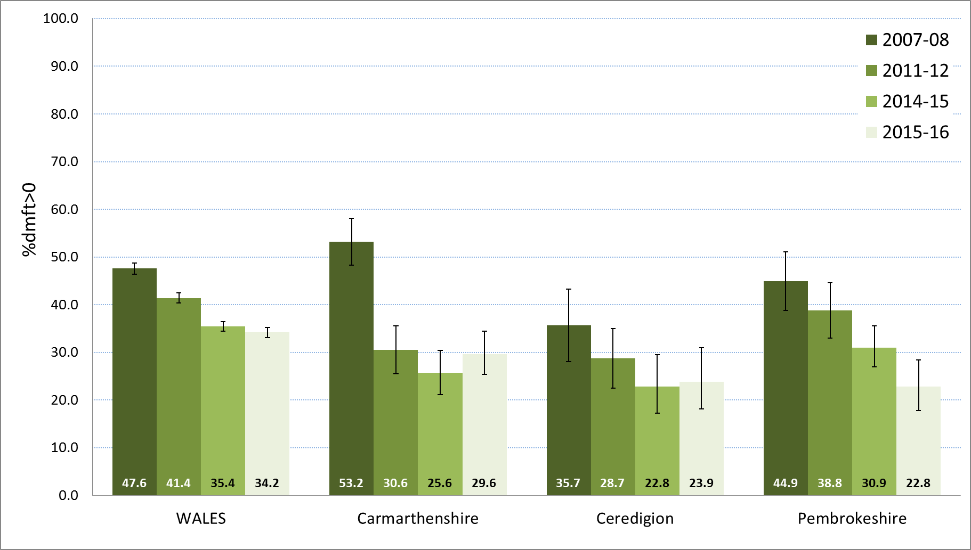

Figure 17 Powys – %dmft>0 by Unitary Authority, 2007/08 to 2015/16

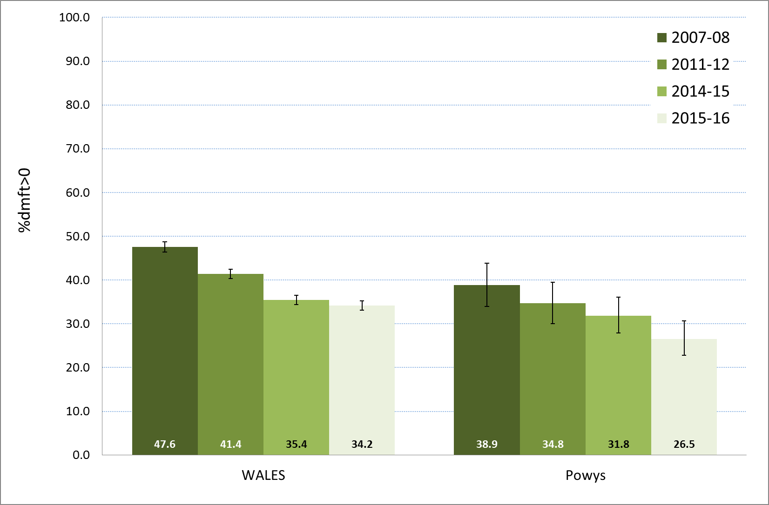

**Appendix 2 Key Dental Caries Variables from the Survey of 5 year olds 2015/16**



Appendix 3 – 2014/15

Appendix 4 – 2011/12

Appendix 5 – 2007/08

**Appendix 3 Key Dental Caries Variables from the Survey of 5 year olds 2014/15**



Appendix 2 – 2015/16

Appendix 4 – 2011/12

Appendix 5 – 2007/08

**Appendix 4 Key Dental Caries Variables from the Survey of 5 year olds 2011/12**



Appendix 2 – 2015/16

Appendix 3 – 2014/15

Appendix 5 – 2007/08

**Appendix 5 Key Dental Caries Variables from the Survey of 5 year olds 2007/08**



Appendix 2 – 2015/16

Appendix 3 – 2014/15

Appendix 4 – 2011/12

**Appendix 6 Interpretation of historical survey data**

This document on the NHS dental survey programme in Wales is the fourth produced since changes had to be made to the consent arrangements for dental examination of school year 1 children (approximately 5-year-old) requiring formal written parental consent.

Data collected before 2006 cannot be compared with data collected from 2007/08. The bias introduced by the changed consent arrangements will never be fully understood because children were not examined if parental consent was not provided.

Decay levels generated from surveys of this age group are recognised as an underestimation of the true experience for three main reasons:

1. Missing deciduous incisors are not included in these calculations because in a few children they may have naturally exfoliated by age 5. All missing incisors are assumed to have been naturally exfoliated although some will in fact have been extracted. Thus the reported decay levels at age 5 are always a slight underestimation of the true decay experience of those children examined in a survey.
2. These surveys employ a visual examination of the child’s mouth, no radiographs are taken. This is another factor which means that reported decay levels underestimate the true disease level.
3. Furthermore, previous research suggests that children who do not participate in the dental surveys are likely to have more decay than those participating,

Thus the mean decay levels in children reported here and in the two previous surveys are likely to slightly under estimate the true decay experience of children aged 5 in Wales.

These underestimates are likely to be present in all four surveys since 2007 to similar degrees. As a result the trends reported by comparison across these surveys will provide a realist picture of changes in decay experience.