

DENTAL EPIDEMIOLOGICAL SURVEY OF 5 YEAR OLD CHILDREN IN WALES 2003/04

SUMMARY REPORT

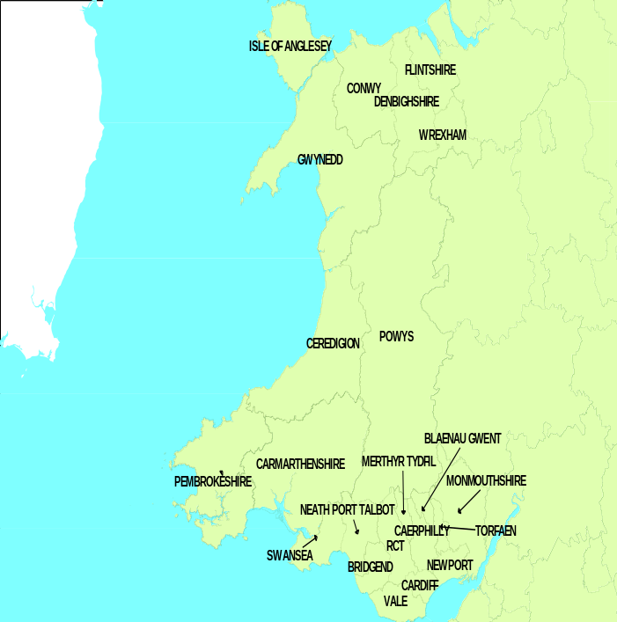

WELSH ORAL HEALTH INFORMATION UNIT


Dental Epidemiological survey of

5 year old children in Wales 2003-2004

Summary:

Tenth survey of dental health of 5 year olds in Wales
Took place between October 2003 and April 2004
11,226 children in school year 1 (33% of year 1 population)

Welsh Assembly Government 48% target levels of decay by 2002

Wales’ overall level of decay in 5 year olds in 2003 - 2004 was 54.43%. 4 Local Health Boards achieved this, one was marginal and 17 have not achieved target level to date.

Mean dmft in Wales
2.42 overall continuing an upward trend (in 1999/2000 the mean dmft was 2.18). Wales mean dmft is higher than England. The 2003/04 mean dmft for England was 1.49.

Severity of caries in children who have experienced decay

Mean dmft of those with dmft>0 for Wales (4.45) is 0.87 of tooth higher than in 2001/02 (3.58).

Dental Epidemiological survey of 5 year old children in Wales 2003-2004

1. Introduction

The childhood dental epidemiological programme collects childhood dental data annually in Wales and targets different age groups in each year. Five year old children are surveyed in alternate years. 12 year olds and 14 year olds are surveyed every second and fourth year in the following cycle 5,12,5, and 14 year olds.
This is the 10th survey of the dental health of 5 year olds in Wales and has been undertaken across all the Local Health Boards that were established in 2003. This report provides an overview of the findings of the survey carried out during the winter of 2003/04. It includes comparisons with results of previous epidemiological surveys undertaken in the Principality and with the rest of the United Kingdom.
In addition, Wales has now progressed beyond the point of comparing performance with targets for 2002 set out in “Better Health Better Wales”, published by the Welsh Office/National Assembly for Wales (now Wales Assembly Government) in 1998. Although at some point it appears that these targets were abandoned as a comparator they are still a useful measurement against which we can map progress in dental health. We are committed to working towards continued improvements in children’s dental health in Wales.
The aim of the 2003/04 survey was to determine current levels of dental caries in 5 year olds in Wales. Information on sampling, training, calibration and dental examinations can be found in Appendix 1.
The average number of decayed teeth can increase because either the proportion of children with decay increases, or because the mean number of decayed teeth among the children with decay increases, or both of these factors increase.
Information on the proportion with decay and the mean number of decayed teeth in children not free from decay follow in sections 3 and 4 respectively. Those interested in reducing health inequalities will be interested in targeting the children with decay reported in section 4.

2. Population mean caries experience

2.1 Mean caries experience in Wales
Table 1 presents the results for Wales, the three Regions and 22 Local Health Boards. It shows the mean number of decayed (d), missing (m) and filled (f) teeth. The table refers to weighted means. Annex A provides an extended table including 95% confidence intervals.
The overall mean dmft for Wales per child is 2.42. This is higher than in 2001/2 (2.26) and is statistically significant (see Annex A).
In comparison with the rest of the UK, mean dmft in Welsh Local Health Boards (BASCD Survey report) ranged from 1.48 in Flintshire (North Wales region) to 3.73 in Merthyr Tydfil (South East region). Scottish Health Boards ranged from 1.29 in Borders to 3.67 in Argyll and Clyde. For English Primary Care Trusts mean values ranged from 0.47 in Maidstone Weald (part of Kent & Medway Strategic Health Authority area) to 3.69 in North Kirklees (part of West Yorkshire SHA area).
Table 1 Epidemiological data by Principality, Region and Local Health Board
AREA TYPE | AREA | Total Population | Children Examined | dt | mt | ft | dmft | Sound
WALES | WALES | 33288 | 11226 | 1.70 | 0.43 | 0.29 | 2.42 | 16.29
REGION | Mid & West | 10812 | 3465 | 1.74 | 0.37 | 0.22 | 2.32 | 16.51
LHB | BRIDGEND | 1561 | 369 | 1.49 | 0.33 | 0.17 | 1.99 | 16.91
LHB | CARMARTHENSHIRE | 1613 | 437 | 2.12 | 0.48 | 0.22 | 2.82 | 16.18
LHB | CEREDIGION | 656 | 202 | 1.57 | 0.29 | 0.33 | 2.19 | 16.93
LHB | NEATH & PORT TALBOT | 1572 | 675 | 1.89 | 0.46 | 0.27 | 2.62 | 15.85
LHB | PEMBROKESHIRE | 1441 | 328 | 1.83 | 0.15 | 0.08 | 2.06 | 17.20
LHB | POWYS | 1460 | 549 | 1.32 | 0.24 | 0.27 | 1.83 | 16.97
LHB | SWANSEA | 2509 | 905 | 1.78 | 0.47 | 0.25 | 2.50 | 16.11
REGION | North Wales | 7507 | 3255 | 1.54 | 0.39 | 0.24 | 2.17 | 16.48
LHB | ANGLESEY | 690 | 344 | 1.55 | 0.57 | 0.44 | 2.56 | 15.87
LHB | CONWY | 1064 | 486 | 1.62 | 0.37 | 0.22 | 2.22 | 16.23
LHB | DENBIGHSHIRE | 916 | 373 | 1.52 | 0.35 | 0.23 | 2.11 | 16.69
LHB | FLINTSHIRE | 2194 | 738 | 1.05 | 0.30 | 0.13 | 1.48 | 17.28
LHB | GWYNEDD | 1307 | 885 | 1.73 | 0.35 | 0.35 | 2.43 | 16.09
LHB | WREXHAM | 1336 | 429 | 2.09 | 0.50 | 0.23 | 2.83 | 15.92
REGION | South East | 14969 | 4506 | 1.75 | 0.50 | 0.37 | 2.62 | 16.03
LHB | BLAENAU GWENT | 790 | 240 | 2.16 | 0.91 | 0.42 | 3.49 | 14.96
LHB | CAERPHILLY | 1753 | 488 | 2.13 | 0.55 | 0.52 | 3.20 | 15.53
LHB | CARDIFF | 3676 | 1363 | 1.44 | 0.41 | 0.36 | 2.21 | 16.40
LHB | MERTHYR TYDFIL | 641 | 151 | 2.22 | 0.96 | 0.54 | 3.73 | 14.84
LHB | MONMOUTH | 866 | 534 | 1.29 | 0.33 | 0.18 | 1.81 | 17.15
LHB | NEWPORT | 1826 | 378 | 1.98 | 0.33 | 0.29 | 2.61 | 16.21
LHB | RCT | 2776 | 653 | 1.94 | 0.67 | 0.43 | 3.05 | 15.54
LHB | TORFAEN | 1122 | 269 | 1.89 | 0.39 | 0.29 | 2.57 | 16.01
LHB | VALE | 1519 | 430 | 1.14 | 0.35 | 0.28 | 1.78 | 16.83
2.2 Mean caries experience in Regions and Local Health Boards
Figure 1: Mean dmft by Region and All Wales 2003/04
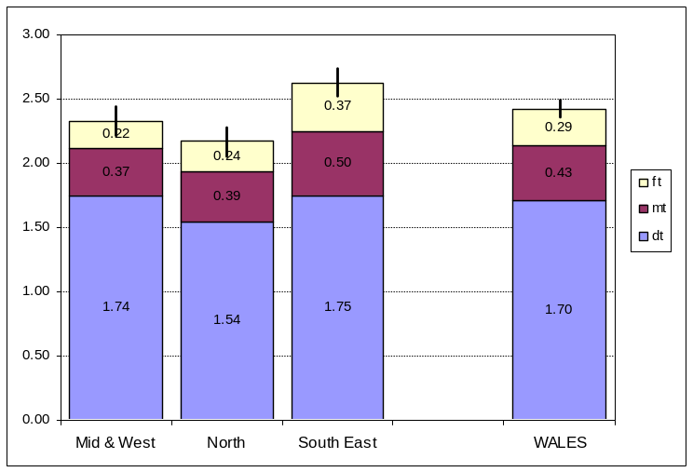
Figure 1 shows the mean dmft values for each of the three Welsh regions and the confidence intervals associated with each mean value.

The 95% confidence intervals represented by error bars at the top of each stacked chart indicate that the differences between North and Mid & West Wales are not statistically significant but that the mean dmft for South East region (mean 2.62; LCI 2.52; UCI 2.73) is statistically higher than the means for the other two regions.
Table 2 shows the mean dmft by the component Local Health Boards of each region. This clarifies the range of mean dmft within the regions. Mid and West Wales ranges from 1.83 in Powys to 2.82 in Carmarthenshire. Mean dmft in North Wales ranges from 1.48 in Flintshire to 2.83 in Wrexham. In South East Wales the mean dmft ranges from 1.78 in the Vale of Glamorgan to 3.73 in Merthyr Tydfil.
Table 2 Mean dmft by Local Health Board
AREA TYPE | AREA | dmft
Region | Mid & West | 2.32
LHB | Powys | 1.83
LHB | Bridgend | 1.99
LHB | Pembrokeshire | 2.06
LHB | Ceredigion | 2.19
LHB | Swansea | 2.50
LHB | Neath & Port Talbot | 2.62
LHB | Carmarthenshire | 2.82
Region | North Wales | 2.17
LHB | Flintshire | 1.48
LHB | Denbighshire | 2.11
LHB | Conwy | 2.22
LHB | Gwynedd | 2.43
LHB | Anglesey | 2.56
LHB | Wrexham | 2.83
Region | South East | 2.62
LHB | Vale | 1.78
LHB | Monmouth | 1.81
LHB | Cardiff | 2.21
LHB | Torfaen | 2.57
LHB | Newport | 2.61
LHB | RCT | 3.05
LHB | Caerphilly | 3.20
LHB | Blaenau Gwent | 3.49
LHB | Merthyr Tydfil | 3.73
WALES | WALES | 2.42
A clearer visualisation can be seen in Figure 2 (below) representing a rough ‘league table’ of the Local Health Boards. The contributions of d, m and f to the overall mean dmft are highlighted by the different coloured shading. The error bars represent the 95% confidence interval for the Local Health Board mean dmft.
Figure 2 Mean dmft for Welsh Local Health Boards
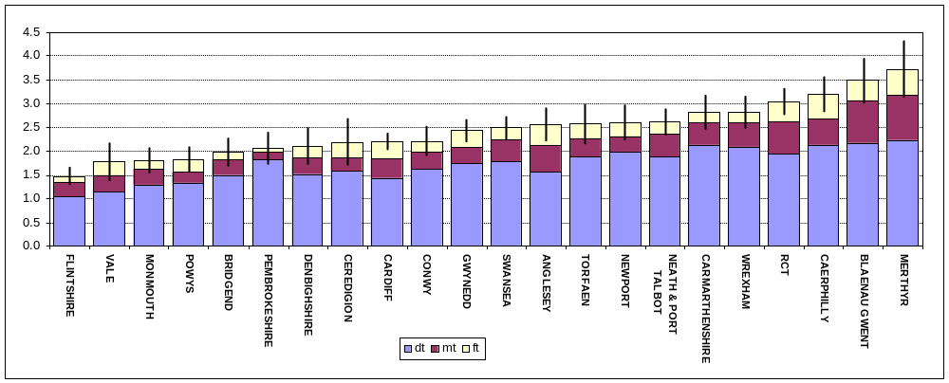

Table 3 presents mean dmft of Local Health Boards and Wales compared with that of the best English Primary Care Trust area Maidstone and Weald PCT (0.47). It is important, at this juncture, to highlight that PCT geographical areas are very different from LHB areas. The total population for Maidstone & Weald is approximately 243,000, whereas Welsh LHB population ranges from approximately 56,000 in Merthyr Tydfil to 305,000 in Cardiff. Numbers examined in the survey of 5 year olds were 359, 151 and 1363 in Maidstone and Weald PCT, Merthyr Tydfil and Cardiff Local Health Boards respectively.

Acknowledging these demographic differences the table below still provides interesting reading, even our best LHB area (Flintshire: mean dmft=1.48) has a mean dmft three and half times worse than Maidstone and Weald. Merthyr Tydfil (mean dmft=3.73) our worst LHB in terms of this characteristic for the current survey had a mean dmft nine times worse than Maidstone and Weald.

Table 3: LHB mean dmft compared with that of the best English PCT
Local Health Board Area | No. of times worse than Maidstone & Weald PCT=0.47
FLINTSHIRE | 3.53
MONMOUTH | 4.40
POWYS | 4.43
VALE | 4.60
BRIDGEND | 4.85
CARDIFF | 5.06
PEMBROKESHIRE | 5.09
DENBIGHSHIRE | 5.30
CONWY | 5.36
GWYNEDD | 5.66
CEREDIGION | 5.68
SWANSEA | 5.81
NEATH & PORT TALBOT | 6.15
ANGLESEY | 6.17
NEWPORT | 6.30
TORFAEN | 6.34
WREXHAM | 6.72
CARMARTHENSHIRE | 6.74
RCT | 7.04
CAERPHILLY | 7.55
BLAENAU GWENT | 8.40
MERTHYR TYDFIL | 9.17
WALES | 5.15

3. Caries prevalence
In 1998 the Wales Assembly Government set a target in its publication ‘Better Health Better Wales” for prevalence of caries. Although this target has been ‘laid to one side’, it stated that no more than 48% of 5 year old school children should have caries by the year 2002. The results of the 2003/4 examinations indicates that this target has been achieved by only 4 out of 22 Local Health Boards. The all Wales average was 54.43% which is a slight increase on the previous survey.

Across the Principality 54.43% of 5 year olds in 2003/04 had a dmft>0, which equated to a 1.5% increase compared with the 2001/02 survey. The regional comparison can be seen in Figure 3 and Table 4 (below).

Figure 3: %dmft>0 by Regional health authorities and Wales, 2001/02 & 2003/04
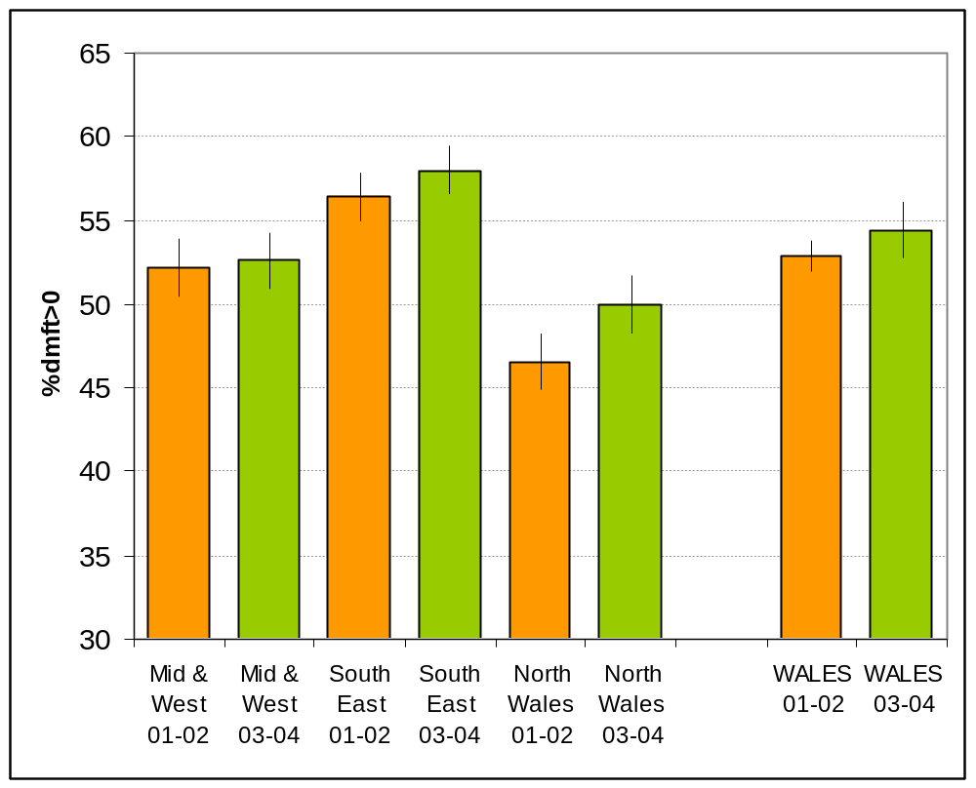

Table 4: 2003/4 levels of decay for 5 year olds’ teeth in Wales by region

 | 2003-04 |  |  | 2001-02
 | %dmft>0 | LCI | UCI | %dmft>0 | LCI | UCI
Mid & West | 52.59 | 50.93 | 54.25 | 52.16 | 50.46 | 53.86
South East | 58.00 | 56.56 | 59.44 | 56.44 | 55.00 | 57.88
North Wales | 49.95 | 48.23 | 51.67 | 46.54 | 44.85 | 48.23
WALES | 54.43 | 52.77 | 56.09 | 52.90 | 51.98 | 53.82

The percent with caries in Mid and West and South East regions were 52.59% and 58% respectively in 2003/04, similar to the 2001/02 figures. North Wales displayed a 3.4% increase between the two surveys, from 46.54% in 2001/02 to 49.95% in 2003/04. However, none of these changes were statistically significant.

Figure 4: %dmft>0 2003/04 compared with WAG target level of 48%
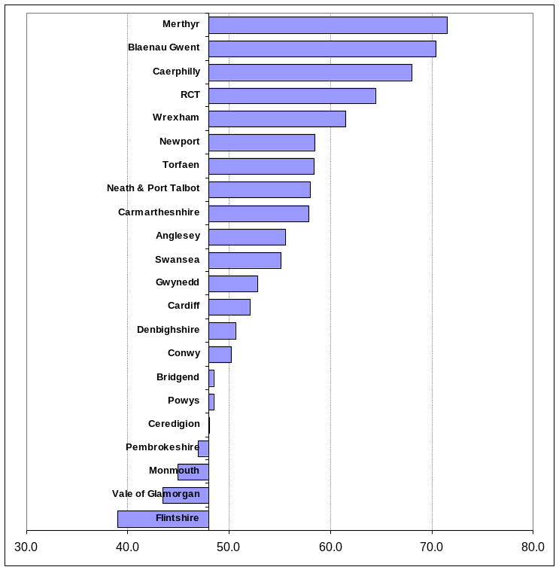

Figure 4 illustrates the level of success in achieving the 48% target level of decay for Local Health Boards, only four achieved this target. Flintshire achieved 39.02% followed by the Vale of Glamorgan with 43.49%, Monmouth with 44.94% and Pembrokeshire with 46.95%. Ceredigion was borderline with a percentage dmft>0 of 48.02%. Two Local Health Boards had levels of decay exceeding 70% (i.e. Blaenau Gwent ,70.42% and Merthyr Tydfil, 71.52%).

Figure 5: %dmft>0 2001/02 and 2003/04 compared with target level of 48%

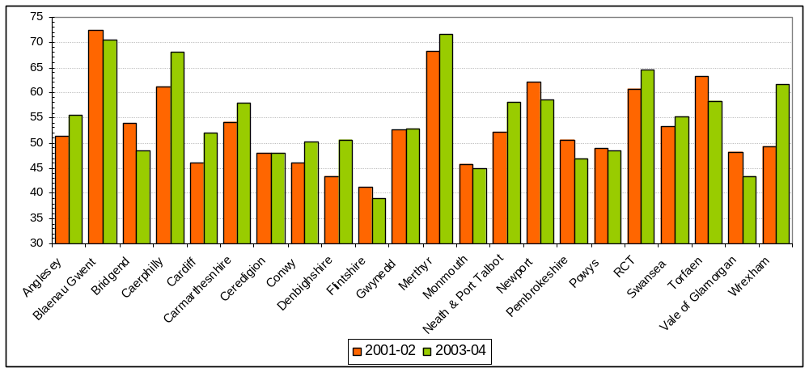

On reviewing the change in %dmft>0 by Local Health Board between 2001/02 and 2003/04, for the worst third as at 2003/04, it can be seen that three LHBs (Blaenau Gwent, Newport and Torfaen) had made some small improvement towards the target, whilst a further four moved further away from the target (Caerphilly, Merthyr Tydfil, RCT and Wrexham).

4. Severity of Caries in children who have experienced decay
Table 5 gives the severity of disease for those with disease. In Wales, children with disease, i.e. 54.43% of those surveyed, had an average of 4.45 (95% lower confidence interval 4.17: 95% upper confidence interval 4.36) teeth decayed missing or filled. This compares with 52.9% in 2000/2001 having an average of 4.27 (95% LCI 4.36: 95% UCI 4.54) carious teeth. Whilst this does not indicate a statistically significant increase in dmft for this group, this trend does not bode well for the future (Annex B).

Table 5 dmft of those with decay experience (i.e. children with dmft>0)
AREA TYPE | AREA | 2003-04 | 2001-02
REGION | Mid & West | 4.41 | 4.24
LHB | BRIDGEND | 4.08 | 4.25
LHB | CARMARTHENSHIRE | 4.87 | 4.59
LHB | CEREDIGION | 4.55 | 4.09
LHB | NEATH & PORT TALBOT | 4.51 | 4.19
LHB | PEMBROKESHIRE | 4.38 | 3.84
LHB | POWYS | 3.78 | 3.99
LHB | SWANSEA | 4.53 | 4.34
REGION | North Wales | 4.33 | 4.00
LHB | ANGLESEY | 4.61 | 4.23
LHB | CONWY | 4.41 | 4.37
LHB | DENBIGHSHIRE | 4.15 | 3.99
LHB | FLINTSHIRE | 3.79 | 3.60
LHB | GWYNEDD | 4.61 | 4.14
LHB | WREXHAM | 4.59 | 4.03
REGION | South East | 4.52 | 4.39
LHB | BLAENAU GWENT | 4.97 | 4.57
LHB | CAERPHILLY | 4.70 | 4.78
LHB | CARDIFF | 4.26 | 4.00
LHB | MERTHYR TYDFIL | 5.19 | 5.00
LHB | MONMOUTH | 4.02 | 3.65
LHB | NEWPORT | 4.46 | 4.53
LHB | RCT | 4.73 | 4.63
LHB | TORFAEN | 4.41 | 4.33
LHB | VALE | 4.10 | 3.77
WALES | WALES | 4.45 | 4.27

A Local Health Board analysis of this characteristic for the 2003/04 survey (Table 5) indicates that Powys had the lowest mean value 3.78 and Merthyr Tydfil the highest, 5.19. On reviewing change in mean dmft of those with caries between 2001/02 and 2003/04 Powys showed an improvement of 0.21 of a tooth (2001/02 mean: 3.99, LCI: 3.60; UCI: 4.37 2003/04 mean 3.78, LCI 3.40; UCI 4.16) compared with Wrexham which demonstrated a 0.56 worsening for this variable (2001/02 mean: 4.03, LCI: 3.61; UCI 4.45 2003/04 mean 4.59, LCI 4.19, UCI 4.99). The 95% confidence intervals do not suggest that these changes are statistically significant (Annex B).

5. DENTAL INDICES FOR WALES

Table 7 presents details of the care, restorative and treatment indices by Local Health Board and Region. The care index expresses the proportion of the caries experience that has been treated restoratively. The care index for Wales indicates that 12% of the teeth with dentinal caries have been restored. Since the teeth assessed in this survey are deciduous teeth it may reflect different dentists’ attitudes to treatment. The LHB values for the care index ranged from 4% in Pembrokeshire in the Mid and West Region to 17%% in Conwy, in North Wales.

Table 7 :Care, Restorative and Treatment Indices 2003/4 for 5 year olds’ teeth in Wales by Local Health Board and Region
AREA | Care index ((f/dmf)x100 | Restorative Index (f/d+f) x100) | Treatment index (m+f)/dmf x100
MID & WEST WALES | 10 | 11 | 25
Bridgend | 9 | 10 | 25
Carmarthenshire | 8 | 9 | 25
Ceredigion | 15 | 17 | 28
Neath & Port Talbot | 10 | 13 | 28
Pembrokeshire | 4 | 4 | 11
Powys | 15 | 17 | 28
Swansea | 10 | 12 | 29
NORTH WALES | 11 | 13 | 29
Conwy | 17 | 22 | 39
Denbighshire | 10 | 12 | 27
Flintshire | 11 | 13 | 27
Gwynedd | 9 | 11 | 29
Wrexham | 14 | 17 | 29
Ynysmon | 8 | 10 | 26
SOUTH EAST WALES | 14 | 18 | 33
Blaenau Gwent | 12 | 16 | 38
Caerphilly | 16 | 20 | 33
Cardiff | 16 | 20 | 35
Merthyr Tydfil | 14 | 20 | 40
Monmouth | 10 | 12 | 28
Newport | 11 | 13 | 24
RCT | 14 | 18 | 36
Torfaen | 11 | 13 | 26
Vale of Glamorgan | 16 | 20 | 35
WALES | 12 | 15 | 30

Figure 6. Care index (5 year olds, 2003/04) and dentists per 10,000 population in Wales, 2004
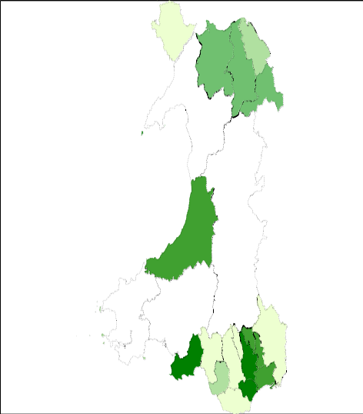
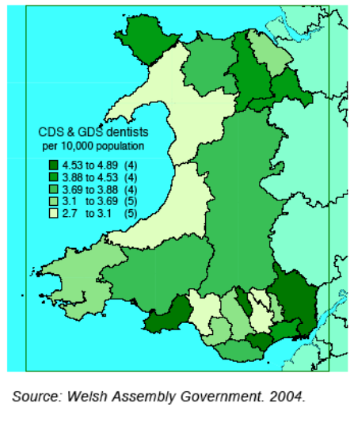
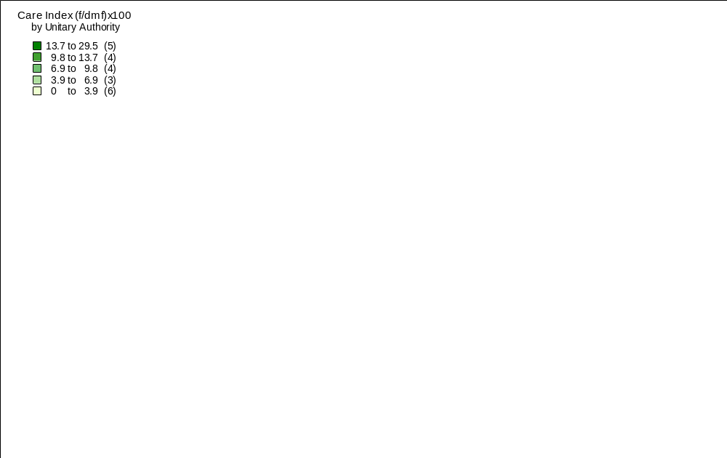
The above figures represent the care index for the 22 Local Health Boards in Wales and the total GDS and CDS dentists per 10,000 population. The maps provide “food for thought” in that there are some LHBs in Wales with comparatively low care indices but with higher concentrations of dentists compared with other LHBs who have better higher indices. This presentation of data could stimulate debate in the coming year.

This report has been produced by Maria Morgan and Professor Elizabeth Treasure, Welsh Oral Health Information Unit, Cardiff University. The authors would like to acknowledge Mr Nigel Monaghan (the all Wales Epidemiology Coordinator) for his specialist editorial input.

The programme is a collaborative venture with the all Wales Epidemiology Coordinator, Local Health Boards, Community Dental Services in Wales NHS Trusts, the Welsh Assembly Government and the WOHIU.

Appendix 1

Sampling, training, calibration and dental examinations
Each Local Health Board was required to identify the number of schools needed to obtain a representative sample of a given size (dependent on Health Board size) from the year 1 population. The sample sizes utilised provide adequate numbers to allow comparisons between Welsh Local Health Boards. The aim was to achieve a 25% sample.

The training and calibration exercises for this year's survey of 5 year olds were coordinated in line with the British Association for the Study of Community Dentistry (BASCD) UK National Training and Calibration guidance and with the Welsh training and calibration group coordinated by the All Wales Dental Epidemiology Coordinator supported by the Welsh Oral Health Information Unit.

The examinations took place between October 2003 and April 2004.

11,226 children were examined representing 33% of the year 1 school population. (i.e. 33288).

Annex A

Table 8 Mean dmft, by Local Health Board with 95% upper and lower confidence intervals

Region | LHB | 2003/04 |  |  | 2001/02
 |  | Mean | LCI | UCI | Mean | LCI | UCI
MW | BRIDGEND | 1.99 | 1.70 | 2.28 | 2.30 | 1.98 | 2.61
MW | CARMARTHENSHIRE | 2.82 | 2.47 | 3.17 | 2.49 | 2.13 | 2.84
MW | CEREDIGION | 2.19 | 1.71 | 2.67 | 1.96 | 1.54 | 2.38
MW | NEATH & PORT TALBOT | 2.62 | 2.35 | 2.89 | 2.19 | 1.94 | 2.44
MW | PEMBROKESHIRE | 2.06 | 1.73 | 2.39 | 1.95 | 1.66 | 2.24
MW | POWYS | 1.83 | 1.58 | 2.08 | 1.95 | 1.67 | 2.23
MW | SWANSEA | 2.50 | 2.27 | 2.73 | 2.32 | 2.07 | 2.56
NW | ANGLESEY | 2.56 | 2.22 | 2.90 | 2.17 | 1.86 | 2.48
NW | CONWY | 2.22 | 1.92 | 2.52 | 2.01 | 1.72 | 2.31
NW | DENBIGHSHIRE | 2.11 | 1.73 | 2.49 | 1.73 | 1.46 | 2.00
NW | FLINTSHIRE | 1.48 | 1.30 | 1.66 | 1.48 | 1.30 | 1.66
NW | GWYNEDD | 2.43 | 2.20 | 2.66 | 2.18 | 1.96 | 2.39
NW | WREXHAM | 2.83 | 2.50 | 3.16 | 1.99 | 1.70 | 2.28
SE | BLAENAU GWENT | 3.49 | 3.03 | 3.95 | 3.31 | 2.89 | 3.73
SE | CAERPHILLY | 3.20 | 2.85 | 3.55 | 2.93 | 2.62 | 3.23
SE | CARDIFF | 2.21 | 2.04 | 2.38 | 1.84 | 1.69 | 1.99
SE | MERTHYR TYDFIL | 3.73 | 3.15 | 4.31 | 3.41 | 2.79 | 4.03
SE | MONMOUTH | 1.81 | 1.55 | 2.07 | 1.67 | 1.39 | 1.94
SE | NEWPORT | 2.61 | 2.26 | 2.96 | 2.81 | 2.16 | 3.46
SE | RCT | 3.05 | 2.79 | 3.31 | 2.81 | 2.57 | 3.06
SE | TORFAEN | 2.57 | 2.16 | 2.98 | 2.74 | 2.35 | 3.13
SE | VALE | 1.78 | 1.40 | 2.16 | 1.82 | 1.51 | 2.12
 | Mid & West | 2.32 | 2.21 | 2.44 | 2.21 | 2.10 | 2.32
 | North Wales | 2.17 | 2.05 | 2.28 | 1.86 | 1.76 | 1.97
 | South East | 2.62 | 2.52 | 2.73 | 2.48 | 2.36 | 2.59
 | WALES | 2.42 | 2.36 | 2.49 | 2.26 | 2.19 | 2.33

Annex B

Table 9 Mean dmft of those with dmft>0, by Local Health Board with 95% upper and lower confidence intervals

 |  | 2003/04 |  |  | 2001/02
Region | LHB | Mean | LCI | UCI | Mean | LCI | UCI
MW | BRIDGEND | 4.08 | 3.65 | 4.51 | 4.25 | 3.82 | 4.68
MW | CARMARTHENSHIRE | 4.87 | 4.46 | 5.28 | 4.59 | 4.14 | 5.04
MW | CEREDIGION | 4.55 | 3.88 | 5.22 | 4.09 | 3.47 | 4.72
MW | NEATH & PORT TALBOT | 4.51 | 4.17 | 4.85 | 4.19 | 3.83 | 4.54
MW | PEMBROKESHIRE | 4.38 | 3.88 | 4.88 | 3.84 | 3.45 | 4.24
MW | POWYS | 3.78 | 3.40 | 4.16 | 3.99 | 3.60 | 4.37
MW | SWANSEA | 4.53 | 4.23 | 4.83 | 4.34 | 4.00 | 4.68
NW | ANGLESEY | 4.61 | 4.18 | 5.04 | 4.23 | 3.78 | 4.67
NW | CONWY | 4.41 | 3.99 | 4.83 | 4.37 | 3.93 | 4.80
NW | DENBIGHSHIRE | 4.15 | 3.60 | 4.70 | 3.99 | 3.59 | 4.39
NW | FLINTSHIRE | 3.79 | 3.48 | 4.10 | 3.60 | 3.29 | 3.91
NW | GWYNEDD | 4.61 | 4.31 | 4.91 | 4.14 | 3.85 | 4.43
NW | WREXHAM | 4.59 | 4.19 | 4.99 | 4.03 | 3.61 | 4.45
SE | BLAENAU GWENT | 4.97 | 4.46 | 5.48 | 4.57 | 4.10 | 5.04
SE | CAERPHILLY | 4.70 | 4.31 | 5.09 | 4.78 | 4.40 | 5.16
SE | CARDIFF | 4.26 | 4.03 | 4.49 | 4.00 | 3.77 | 4.23
SE | MERTHYR TYDFIL | 5.19 | 4.58 | 5.80 | 5.00 | 4.30 | 5.71
SE | MONMOUTH | 4.02 | 3.60 | 4.44 | 3.65 | 3.17 | 4.12
SE | NEWPORT | 4.46 | 4.00 | 4.92 | 4.53 | 3.77 | 5.29
SE | RCT | 4.73 | 4.44 | 5.02 | 4.63 | 4.32 | 4.93
SE | TORFAEN | 4.41 | 3.89 | 4.93 | 4.33 | 3.88 | 4.77
SE | VALE | 4.10 | 3.47 | 4.73 | 3.77 | 3.32 | 4.22
 | Mid & West | 4.41 | 4.26 | 4.57 | 4.24 | 4.08 | 4.39
 | North Wales | 4.33 | 4.17 | 4.49 | 4.00 | 3.85 | 4.16
 | South East | 4.52 | 4.39 | 4.66 | 4.39 | 4.24 | 4.54
 | WALES | 4.45 | 4.36 | 4.54 | 4.27 | 4.17 | 4.36

