STUDENT CARD REQUEST FORM 2021/2
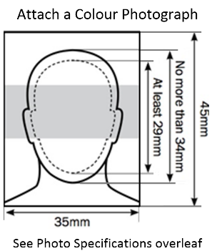 (Distance Learning Programme Only)
All sections need to be completed

Cardiff University Student Card

If you are studying on a distance learning programme and you may use resources or facilities on Cathays Park or Heath Park Campus during your study, please tick the box below to apply for a full Cardiff University Student card.
(This card will act as a Library and e-learning card, proximity access card and University identity card).
You will need to attach a colour passport sized photograph above, please note the ‘Photograph Specifications’ overleaf
You will need to contact your school as to how to collect this card.
I wish to apply for a Cardiff University Student Card

Please electronically attach a colour passport photograph to this document or physically attach your photograph in the box at the top right of the form. If you are physically attaching the photograph please write your full name on the reverse of the photograph and ensure it is secured to the form by paperclip, please do not staple.
NB: Photograph specifications are listed on the reverse of this form
Student No. |  |  | Title |  | First Name |  |  |  | Surname / Family Name |  |  |  |  |  | Date of Birth
School / Dept.(*) |  |  |  |  |  | Programme (Course) |  |  |  | Start Date |  |  | End Date
(*) Your school will arrange distribution of this card.
Signature: |  |  |  |  |  |  |  |  |  |  | Date:
 | For School Office Use Only – MUST be completed prior to submission to security
 | Please authorise the issue of a student card for the above, enter the name and address of the school contact you wish the Students ID card to be returned to for distribution to the student, once complete send this form to the Security Centre, Park Place:
 | School Authorisation – (If not completed, ID Card will not be issued)
 | Name: |  |  |  |  |  | Signature: | . . |  |  |  |  | Date: |  |  | .
 | Return | Address Line 1
 |  | Address Line 2
 |  | Address Line 3
 |  | Address Line 4

Student Card Request Form – Photograph Specifications
NB: These specifications mirror those of a Passport/Driving licence photograph and can be obtained in most automated photo booths.
The photograph must be:
- In colour on plain white photographic paper
- Taken against a plain or light coloured background
- Clear and in focus
- Without any tears or creases
- Unaltered by computer software
The image of you
- Photos should show a close-up of full head and shoulders. It must be only of the applicant with no other objects or people.
- The image of the applicant's head - from the crown of the head to the chin - should be sized between 29 millimetres and 34 millimetres deep (see example below)
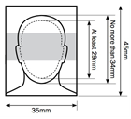
Your photo may be rejected unless it shows you:
- Facing forward and looking straight at the camera
- With a neutral expression and mouth closed
- In clear contrast to the background
- Without a head covering (unless it’s worn for religious or medical reasons)
- With eyes open, visible and free from reflection or glare from glasses
- With your eyes not covered by sunglasses, tinted glasses, glasses frames or hair
- Without any shadows in the picture

