ISSF End of Project Report
Guidance Document

Introduction

As part of Cardiff University’s Wellcome Trust ISSF programmes, we are required to report outcomes from our funding to the Wellcome Trust. To facilitate this, we have developed a new online system for ISSF awardees to use to report their outcomes, both within a month of finishing the award, but also beyond that as required.

The online system is accessible at: https://cardiff.onlinesurveys.ac.uk/issf3-end-of-project-report

For information, the system includes data capture categories aligned with the Researchfish® system (see below). This approach allows us to collect information in a form aligned to external reporting approaches, but also gives early career researchers experience of how major funders typically capture grant outputs.

Researchfish® is an online system which enables researchers to report their research outcomes to funding organisations. It is used by all the UK’s Research Councils to capture the outcomes and longer-term impact of research. For further information see:

http://www.rcuk.ac.uk/research/researchoutcomes/, https://www.researchfish.net/ and
https://app.researchfish.com/questions

The key outputs collected by Researchfish® is shown below.

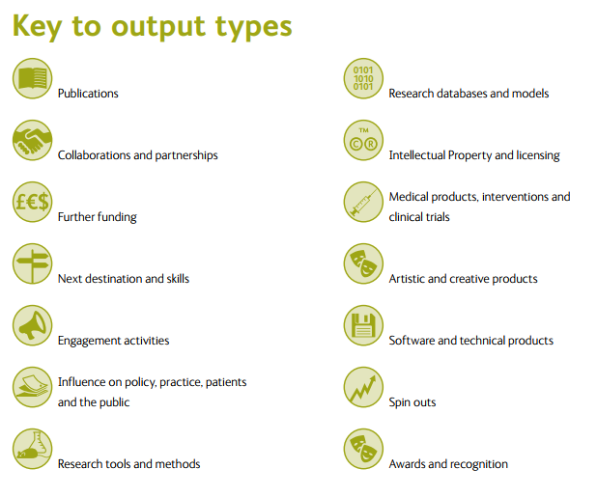

The ISSF End of Project Report contains both free text prose sections and output categories derived /amalgamated from the Researchfish® ‘common question set’.

ISSF END OF PROJECT REPORT OVERVIEW:

The report is spilt into three sections, all of which need to be completed by researchers:

  - Section 1: Project Overview
  - Section 2 - Outputs: Research and Project
  - Section 3 - Outputs: Career Development

Page 1 - Section 1: Project Overview

- Project & PI Details:

- 1) Name of the PI
- 2) ISSF 2 or ISSF 3 award
- 3) ISSF Award Scheme
- 4) Project Title

Please supply project details as originally described in your application. This facilitates accurate linking of applications and outcomes.

- Research/Project Summary: (Free Text boxes- prose narrative)

- 5) Key Experimental Findings:

Please describe the key scientific / experimental observations and conclusions from the project.

- 6) Project Impact:

Please describe the impact and wider relevance of the project. We are interested in knowing, beyond the scientific advances, if this project been shared with and / or influenced wider non-academic stakeholders.

- 7) Career Development:

Please describe how the project has benefited the career development of the PI. We are interested in transition to independence in those with early career awards, new skills and collaborations and increased competitiveness for external funding for the work? Please also describe how the project has benefited the career development of staff employed on the project.

Please note: All of these sections should be written to be accessible to non-experts in the field and with reporting to funders in mind. We will use information provided for us on the Cardiff University website to highlight outcomes from projects.

Page 2 – Section 2: Research / Project Outputs

- Output capture: Researchers should provide bullet point examples of specific research outputs separated into the categories provided in the online form. Section 2 focuses on research and project outputs with career development being covered in Section 3.

- Please note: not all categories will be appropriate for all ISSF projects. Please note in such sections – Not Applicable. Further, please include only information directly attributable to the ISSF project funding (e.g., outputs/ outcomes that would not have happened without this funding).

- 8) Publications (Peer-reviewed academic literature)
- Journal Article / Review
- Book or Book Chapter
- Conference Proceeding / Conference Paper
- Consultancy Report
- Manual / Guide
- Policy Briefing Report
- Systematic / Technical Review
- Other

- 9) Research Databases, Tools, Methods & Software (development of new databases, methodologies, capabilities or software/ instrumentation for data collection or analysis)
- Biological samples / Cell lines / Antibodies
- Technology assay or reagent
- Model of mechanisms or symptoms - in vitro / in vivo
- Physiological assessment or outcome measure
- Improvements to research infrastructure
- Software, Webtool / Application / Computer models / Algorithms
- New Material / Compound
- New or Improved Technique / Technology
- Systems, Materials & Instrument Engineering
- Data analysis technique

- 10) Intellectual Property, Licensing, Products, Medical Interventions & Clinical Trials (protection and management of intellectual creations)
- Copyright material (e.g. software)
- Patent application
- Patent granted
- Trademark
- Diagnostic tool / Potential biomarker
- Therapeutic Intervention
- Commercially released product
- Clinically authorised apparatus / tool / procedure / service used in the treatment, mitigation, diagnosis or prevention of disease

- 11) Collaborations, Partnerships & Leverage of Resources (arrangement in which two or more parties were involved in providing input into the project)
- Details of the collaboration and/or partner(s)
- For each Partner – describe what this collaboration or partnership brought to the project in terms of knowledge, data, skill sets
- For each Partner - please describe the growth and development of the collaboration. Where you were and where you are now in developing the relationship?
- Please also provide details of any in-kind (data, materials, consumables) or direct financial contribution to your research?

- 12) Engagement Activities and Influence on Policy, Practice or Public (the involvement of specialists and non-specialists in knowledge exchange, including culture change in key stakeholders)
- Presentation or panel debate
- Magazine or newsletter articles (print or online)
- Development / contribution to formal working group or expert panel
- Hosting an event, workshop or similar
- Media interview, press release, press conference or contribution to the media
- Engagement focused website, blog or social media channel
- Influence on Policy – citation in policy documents / clinical guidelines
- Participation in advisory committee
- Influenced training, regulation, practice guidelines
- Attracted visiting staff or end-user to your research group

Page 3 – Section 3: Career development outputs

- Outputs capture: Researchers should provide bullet point examples of specific examples aligned to research sustainability, transition to independence and career development facilitated by the project.

- 13) Training, Skills and Development
- Training courses undertaken or facilitated
- New key technical skills acquired
- Professional development courses (including public engagement)
- Transferable skills acquired

- 14) Next Destinations (Staff career progression – tracking changes in jobs facilitated by the project, both PIs, co-Is and staff employed on the project)
- University / educational institutions
- Company (all private companies including social enterprises)
- Charity sector
- Hospital / health care provider
- Public Sector
- Learned Society
- Unknown

- 15) Awards & Recognition (community recognition in honour of a project/ researcher achievement, please not whether for PI, co-I or staff)
- Research prize
- Conference / poster / abstract prize
- Public citation / performance recognition
- Promotion

- 16) Further Funding & Future Steps (additional funding that continues the advancement of the project outputs and/or the future steps)
- Research grant (funder, value)
- Fellowship
- Studentship
- Capital/infrastructure (including equipment)
- Travel
- Public or other forms of engagement

- 17) Support for Equality & Diversity (Contribution to promoting an equal and inclusive culture for all staff and students)
- Training / awareness courses / activities
- Promotion / advocacy / outreach
- Data management methodologies applied to address E, D & I
- Implemented / Embedded improved procedures/ processes
- New monitoring and / or evaluation procedures

- 18) Other Outputs
- Any other outputs, outcomes or impacts resulting from this project that do not fit easily into the previously described categories

