  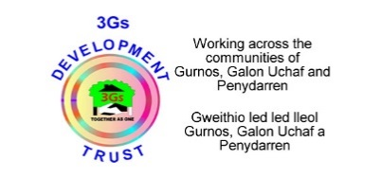 

**Reporting and proposing activities to be linked with**

**Communities First Priorities**

This form has been developed to identify how current and future activities map onto Communities First Priorities. The full process is set out below:-

1.       Proposer completes and submits form to Mel Evans at Evansm6@cardiff.ac.uk.

2.       CF Leeds/Working group review and make recommended changes to fit with priorities.

3.       Feedback given to proposer.

4.       Dependant on level of changes required these will either go back to the working group or be circulated to all partners where there may be potential partnerships forged.

5.       Activities will then be added to the overall table of events.

6. We will contact you after the activity has taken place to gather information on how this met Communities First targets.

**Should you require any further information please contact Mel Evans in the first instance at** [**Evansm6@cardiff.ac.uk**](mailto:Evansm6@cardiff.ac.uk)

Pioneer Initiative

Activity Proposal Submission

|  |  |
| --- | --- |
| **Proposer** | |
| Name |  |
| Group/Company |  |
| Title of Proposal |  |
| Outline of proposed activity/project |  |
| Which CF Area(s) is this Activity?    Which CF cluster area(s) will the activity take place? |  |
| Which CF Priority is this linked  Please identify which CF theme and priority target the activity identifies with. | Theme and Priority : Choose an item., Choose an item. Choose an item. |
| Theme and Priority : Choose an item., Choose an item. Choose an item. |
| Theme and Priority : Choose an item., Choose an item. Choose an item. |
| Please provide a summary of how this links to CF priorities |  |
| Activity Date |  |
| Activity Location |  |
| Resources (e.g. Funding, materials that can be offered/shared with other partners) |  |
| From the list of partners on our website are there any resources/groups you would find of benefit to your project? http://bit.ly/1iYKBNR |  |
| If you would like to involve Cardiff University student volunteers in your activity please give details in terms of numbers and how they may help. |  |
| How will you be evaluating the Activity |  |

|  |  |
| --- | --- |
| **For Completion by Communities First Lead** | |
| Does this meet intended priorities? |  |
| Are there any changes to make it fit better with key priorities |  |
| Any Feedback to proposer? E.g. who they need to contact to link with groups in CF areas, recommended changes to proposal etc) |  |