Midwifery Assessment Tool for Education (MATE)
MATE is an evidence-based guide for countries wishing to strengthen/develop midwifery education.  MATE has been created and piloted with support of midwifery colleagues in Europe.  MATE is a self-assessment tool designed to inform discussions in country at early planning stages, and belongs to the midwives /leaders who use it. It asks midwives, leaders and women using maternity services to consider:  - Where they are now?  - Where they would like to be?  - What they need to do to get there?  - It also provides links to useful resources  Developing MATE:  - Jan 2017 – July 2017  Expert group consultation: Lithuania, Slovakia, Slovenia, Bulgaria  - 2018: Pilot in Eastern Europe  In Czech Republic and Lithuania. We asked: Is MATE fit for purpose? Is it relevant, understandable and useful?  - 2018-19: Field-test in Eastern Europe  To ensure that the process of using MATE is understandable and effective.  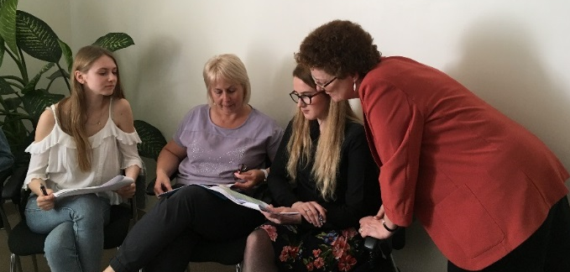  Piloting MATE in Kaunas, Lithuania | Sample pages from MATE:  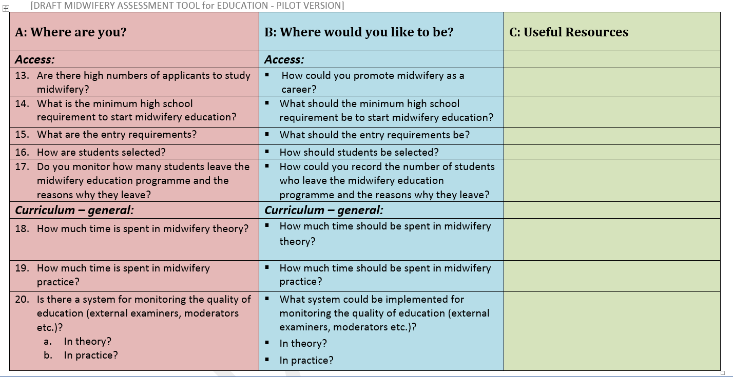  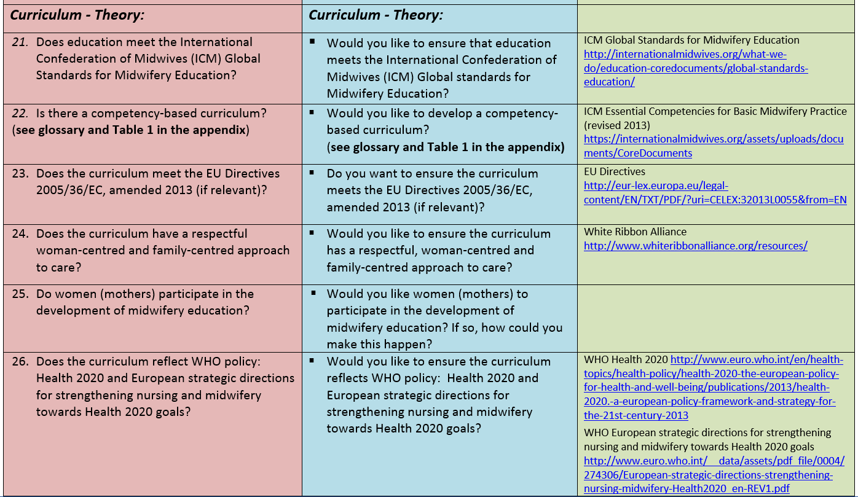  Participant feedback from the pilot stage was very positive. Participants told us:  - ‘It can help to think and to do real steps for development of midwifery’  - ‘It is relevant in my country, but there are many countries whose system is struggling a lot more than us. I'm sure this tool can help them make it better’  Following field-testing, the tool will be translated and published on WHO website.  For further information please contact:  WHOCCmid@cardiff.ac.uk

