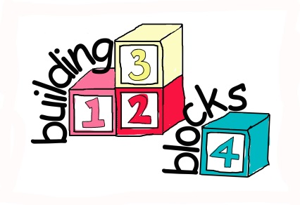

Building Blocks Trial Privacy Notice
September 2018

The Building Blocks trial completed and reported to the Department of Health in 2016. The original participant information sheet that participants received and consented to can be found in Appendix 2 of the final report which details what the trial was, what participation involved and how the research team would use the data provided.

The study is now being archived, which means no further analysis is being conducted on the data, but for regulatory reasons we are required to retain for up to 30 years from the study end date. This was detailed in the original participant information. Cardiff University, acting on behalf of the sponsor and Data Controller (Department of Health) will retain all data collected as part of the trial for this duration. This includes data provided under licence from NHS Digital such as hospital records – this includes dates of attendance/admission, codes relating to diagnosis and/or treatment but no identifiable data. Identifiable data collected as part of the trial is stored separately to the data used for analysis and will be destroyed when it is no longer necessary to keep this information.

York University conducted the health economics analysis for the trial and data was made available to them however, now that the analysis is complete this data has now been deleted.

To find out how we used the data you provided, please read the publications available on our project website.

To find out your rights (including contact details for any queries you have) under the General Data Protection Regulation and UK Data Protection Laws please follow this link.

The legal basis for processing identifiable data for research purposes under GDPR is task in the public interest and for processing special categories this is necessary for archiving purposes in the public interest and scientific purposes. For information on what this means please follow this link.

