
Audit of Radiotherapy Clinical Education Placements

October xxxx

- Clinical Education

Clinical education is represented by the periods of the course which students spend in radiotherapy and oncology departments. During the three years of the course, each student will rotate through each of the three radiotherapy and oncology departments participating in the scheme:
- Betsi Cadwaladr University Local Health Board, Bodelwyddan
- Singleton NHS Trust, Swansea;
- Velindre NHS Trust, Cardiff.

The programme has been designed to allow interaction of academic studies with the clinical experience gained by the student. The programme consists of blocks of varying lengths, which enable the students to consolidate their practice. These periods also offer opportunities for the students to reflect upon and consider the application of the knowledge acquired during the academic blocks.
The total duration of the course is approximately xxx weeks. Each academic year is divided into academic and clinical education blocks ranging from x to x weeks in duration. The annual block plan is designed so that there is no overlap of students in the clinical department at any one time. The exception to this is the minimal overlaps where more senior students are offered the opportunity to enhance their own teaching skills by acting as mentors for junior students.

2. Validated Places
The school has requested that the radiotherapy and oncology departments participating in the scheme are validated for student places as follows:

Department | Student places per cohort
Betsi Cadwaladr University Local Health Board, Bodelwyddan | 4/5
Singleton NHS Trust, Swansea | 7/8
Velindre NHS Trust, Cardiff | 11/12

3. Level Descriptors
In clinical, the skill level of the student should be considered on an individual basis rather than their year of study. The following level descriptors define a minimum achievement linked to the learning outcomes for each module of study.

3.1 Level 4 Descriptor
The acquisition of basic skills and knowledge which acts as a foundation for subsequent learning. Evaluation and analysis is undertaken with guidance. Students begin to develop strategies in problem solving, leading to a grasp of the fundamental principles of diagnostic imaging or radiotherapy and oncology. Whilst clinical education operates within closely defined guidelines, students will have the opportunity to evolve their skills through observation and practise.

3.2 Level 5 Descriptor
Application of skills and knowledge to problems encountered with evaluation and analysis being developed under minimal guidance. This will lead to a greater degree of confidence and autonomy, particularly in the clinical setting.

3.3 Level 6 Descriptor
Thorough knowledge of subjects applied to both academic and clinical settings through a process of reflection and synthesis. Within the clinical situation students will begin to act as competent and professional practitioners working autonomously as individuals within the healthcare team.

4. Monitoring & Evaluation of Clinical Learning Environments

A review process is carried out in order to monitor the clinical learning environment. The clinical learning environments utilised by this scheme are monitored & evaluated in relation to the following criteria:
- provide a stimulating learning environment which enables the learning outcomes to be achieved;
- have sufficient numbers of clinical staff with a clear understanding of their roles and responsibilities in relation to the support of students and their education;
- are able to demonstrate ongoing staff training, to include a robust staff development programme;
- have an adequate level of facilities to support the given number of students;
- have clearly established lines of communication and liaison with the education provider;
- demonstrate compliance with current legislation including Health & Safety Legislation and IR (MER) Regulations.

The review process entails an annual audit of each clinical learning environment. The audit document is based on a number of identified, measurable standards related to two key processes:

 |  | Annual Audit
Environmental Process |  |  |  | Management Process
Audit of the clinical learning environment |  |  |  | Audit of the management of the student’s clinical education

The Auditing Process
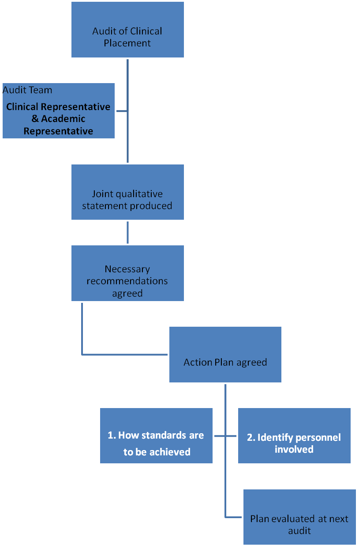

Environmental Process

Radiotherapy Clinical Education Audit
Audit Site | Betsi Cadwaladr University Local Health Board, Bodelwyddan
Total number of patients/year
Radiotherapy Services Manager:

Clinical Lecturer:

Audit in preparation  for period | For academic year xxxx - xxxx  Collated xxxxxxxx
Audit Team

Clinical Stations: | Treatment & Support
Linac A (Awel)
Linac B (Bala)
Linac G (Gorwel)
Linac F (Ffynnon)
SXR (Derwen)
CTscanner/dosimetry
Ward

Radiology equipment
Clinical Stations: | Diagnostic X-ray
General Radiography
CT scanner
MRI scanner
Mammography
Ultrasound
Gamma Camera
Screening
Interventional

Radiotherapy Clinical Education Audit

Audit Site | Swansea Bay, University  NHS Trust , Swansea
Number of new patients/year (new courses of radiotherapy excluding old patients having further treatment)
New & old courses combined
Radiotherapy patient treatment attendances
Total number of patients/year (all patients seen
in marking sessions & on-treatment review)
Radiotherapy Services Manager:
Clinical lecturer
Audit in preparation  for period | For academic year xxxxxxxxxx  Collated xxxxxxxx
Audit Team

Give details of clinical stations and equipment.
Give details of any new equipment or amend as appropriate.
Clinical Stations: | Pre-Treatment Planning
Simulator
CT Simulator
Mould Room
NB. Very limited student access
Radiotherapy Planning suite & Calculations Site

Clinical Stations: | Treatment & Support
Linac 1
Linac 2
Linac 3
Linac 4
Linac 5
Ward
Radiotherapy Clinic
Chemotherapy Clinic

Equipment/ Model | Diagnostic X RayDepartment Singleton
General X ray
4 rooms
Fluoroscopy
Mammography Room
Mobiles

Image intensifiers

PACS
Ultrasound Rooms
Endoscopic Ultrasound equipment
MRI
CT scanner

Radiotherapy Clinical Education Audit

Audit Site |  | Velindre Cancer Centre, Cardiff
Number of new patients/year
Total number of patients/year

Radiotherapy Services Manager:
Audit in preparation
for period
Audit Team

Give details of clinical stations and equipment.
Give details of any new equipment or amend as appropriate.
Clinical Stations: | Pre-Treatment Planning

Offices

Mould Room
CT Simulator
1
CT Simulator
2
Specialist Roles
Quality Assurance
(not appropriate for student training)
Treatment Planning

Clinical Stations: | Treatment & Support
H Drive
Linac 1

Linac 2
Linac 3

Linac 4

Linac 5

Linac 6

Linac 7
Linac 8

DXR

Brachytherapy
On-Treatment Review & Information and support
Research /Innovation & Development
Radiographers
Specialist Radiographers

Clinical Stations: | Diagnostic X-ray & Nuclear Medicine
General Radiography & Fluoroscopy
CT scanner
MRI scanner
Ultrasound
Gamma Camera
Unsealed Source Treatments

All students have the opportunity to gain a range of formative clinical experiences in order to complete the following Clinical Placement Goals:

Afterloading / Brachytherapy  The student should be able to: | Velindre | Singleton | Glan Clwyd
demonstrate awareness of the types of brachytherapy
demonstrate awareness of the sources available for brachytherapy
demonstrate awareness of the half-life of the sources
demonstrate awareness of the particles emitted
demonstrate awareness of the implications of a source change
observe the use of sealed sources
explain the aim and application of brachytherapy for different conditions
understand the treatment console/computer
describe what is observed on the computer screen
put together the obturator correctly
dismantle to obturator and pack
send obturator packs to SSU
explain the treatment prescription and instructions on the treatment sheet
prepare the treatment room for the patient
greet, collect and correctly identify the patient
observe the use of ultrasound image guidance
describe the intracavitary procedure
describe the vaginal vault procedure
clean the equipment used following the treatment
understand & assist with daily quality assurance checks
describe the emergency "source sticking" procedure
demonstrate knowledge of relevant treatment calculations
demonstrate knowledge of relevant treatment calculations

demonstrate awareness of the first day chat procedure
demonstrate awareness of the last day chat procedure
demonstrate awareness of the need for dilators
demonstrate the information that should be given regarding the use of dilators to another person
Explain the reasons for the long-term follow-up procedure
Demonstrate knowledge and understanding via a clinical case report
Chemotherapy  The student should be able to: | Velindre | Singleton | Glan Clwyd
briefly discuss the specific drug regimens used for two cancers:
regime 1
regime 2
briefly discuss the specific drug regimens used for chemo-radiotherapy treatments:
regime 1
regime 2
observe the administration of IV chemotherapy
discuss the precautions taken during administration
demonstrate understanding of the following chemotherapy terms:
neo-adjuvant
adjuvant
concurrent
combination
explain the various routes of chemotherapy administration
outline the action to be taken in the event of a chemotherapy spillage
discuss the importance of blood tests when giving chemotherapy
indicate the action to be taken for a neutropenic patient
explain the term “extravasation” and how this is treated
observe a PICC line insertion
outline the care and management for the following acute chemotherapy side effects:
Nausea and vomiting
diarrhoea
Plantar palmer syndrome
Mouth ulcers
Hair loss
Clinic  The student should be able to: | Velindre | Singleton | Glan Clwyd
Outline the principles of wound care
Explain the use of the contents of the emergency trolley
Discuss the care of patients undergoing oxygen administration
Discuss the care of patients undergoing oral suction
Research  The student should be able to: | Velindre | Singleton | Glan Clwyd
Access to current trial information
Dosimetry / Treatment Planning  The student should be able to: | Velindre | Singleton | Glan Clwyd
Perform calculations for: electrons
kilovoltage
megavoltage % depth dose
tissue phantom ratio
tissue maximum ratio
extended FSD
Discuss the following features of a computer plan:
gross tumour volume
clinical tumour volume
planning target volume
beam arrangement
beam energy
inhomogeneities
weighting
wedges
hinge angle
isocentre
normalisation
tolerance doses
dose constraints
produce a computer plan applying the following techniques:
parallel opposed pair
three field plan
four field "brick"
produce acceptable 2D computer plans for the following regions:
chest
head & neck
breast
pelvis
produce acceptable 3D-CRT computer plans for the following regions:
chest
pelvis
brain
Megavoltage  The student should be able to: | Velindre | Singleton | Glan Clwyd
set treatment parameters using console / handset
manoeuvre and immobilise the treatment couch
demonstrate the correct handling of the:
breast board
head and neck board
accessory equipment
demonstrate the correct handling of these manual handling devices:
airpal/slide/glide sheets
wheelchair
stretcher
standing hoist
hoist
demonstrate good manual handling practice
demonstrate excellent manual handling practice
demonstrate the correct hygiene precautions
demonstrate the correct hand washing procedure
greet and correctly identify patients
position patients on the treatment couch unaided
demonstrate the correct use of the control panel with assistance
demonstrate the correct use of the control panel with minimal assistance
observe the acquisition of treatment verification images
assist the acquisition of treatment verification images
perform the acquisition of treatment verification images
observe treatment verification image matching
assist treatment verification image matching
perform treatment verification image matching
demonstrate understanding of the correction of random and systematic errors.
demonstrate understanding of imaging protocols for site specific regions: BREAST
Megavoltage  The student should be able to: | Velindre | Singleton | Glan Clwyd
demonstrate understanding of imaging protocols for site specific regions: HEAD & NECK
demonstrate understanding of imaging protocols for site specific regions: LUNG
demonstrate understanding of imaging protocols for site specific regions: PROSTATE
act as a member of the team for a radical breast treatment technique to a competent level
act as a team leader for a radical breast treatment technique to a competent level
act as a member of the team for a radical thorax treatment technique to a competent level
act as a team leader for a radical thorax treatment technique to a competent level
act as a member of the team for a radical pelvis treatment technique to a competent level
act as a team leader for a radical pelvis treatment technique to a competent level
act as a member of the team for a radical head & neck treatment technique to a competent level
act as a team leader for a radical head & neck treatment technique to a competent level
describe the steps needed to implement a new radiotherapy prescription.
enter patient data into a networked verification system.
assist with daily quality assurance checks on 1st linear accelerator
perform daily quality assurance checks on 1st linear accelerator
assist with daily quality assurance checks on 2nd linear accelerator
perform daily quality assurance checks on 2nd linear accelerator
assist with daily quality assurance checks on 3rd linear accelerator
perform daily quality assurance checks on 3rd linear accelerator
assist with daily quality assurance checks on 4th linear accelerator
perform daily quality assurance checks on 4th linear accelerator
observe the monthly quality assurance procedures on a linear accelerator
demonstrate communication skills with a patient to fair level
Megavoltage  The student should be able to: | Velindre | Singleton | Glan Clwyd
demonstrate communication skills with a patient to good level
demonstrate communication skills with a patient to very good level
demonstrate communication skills with a patient to an excellent level
prepare a new patient for radiotherapy treatment to the HEAD & NECK (first day chat)
prepare a new patient for radiotherapy treatment to the BREAST (first day chat)
prepare a new patient for radiotherapy treatment to the THORAX (first day chat)
prepare a new patient for radiotherapy treatment to the PELVIS (first day chat)
work within a team to safely deliver a radiotherapy treatment for a patient with a pacemaker device.

outline the processes required for the monitoring of a pacemaker device during a course of radiotherapy.

demonstrate knowledge and understanding via a clinical report for a patient with a carcinoma in the BREAST region
demonstrate knowledge and understanding via a clinical report for a patient with a carcinoma in the PELVIS region
demonstrate knowledge and understanding via a clinical report for a patient with a carcinoma in the THORAX region
demonstrate knowledge and understanding via a clinical report for a patient with a carcinoma in the HEAD & NECK region
Quality Systems  The student should be able to: | Velindre | Singleton | Glan Clwyd
Demonstrate awareness of the importance of the following:
Departmental protocols
Raising & escalating concerns
Risk Awareness
Incident Reporting Systems
Non-conformance procedures
Departmental statistics / Record keeping
Clinical audit
Clinical governance
Continuous Professional Development
Document: Towards Safer Radiotherapy
Document: On Target
Safeguarding (Adults)
Safeguarding (children)
GDPR/Information Governance
On-Treatment Review  The student should be able to: | Velindre | Singleton | Glan Clwyd
greet and correctly identify patients
observe an ENT examination
attend an MDT meeting
describe the procedure for the collection of:
Blood samples
Urine samples
Sputum samples
with regard to the analysis of blood, indicate the appropriate action for a patient with a:
Low haemoglobin level
Low neutrophil count
Low platelet count
Raised urea & creatinine levels
Raised liver function
perform the following observations:

Pulse
Respiration
Blood pressure
describe the radiation reactions and aftercare for patients with:
Ca Oropharynx
Ca Breast
Ca Lung
Ca Prostate
Ca Cervix / Endometrium
Ca Rectum
have a good understanding of acute radiotherapy toxicity tools e.g. RTOG
awareness of the radiographer’s role in the prescription of medication
under supervision, review a patient receiving a course of radiotherapy
under supervision, review a patient receiving a course of radiotherapy for ca prostate

under supervision, review a patient receiving a course of radiotherapy for ca breast

attend an open evening
Visit a Maggie’s centre
Radiotherapy Simulation/Planning  The student should be able to: | Velindre | Singleton | Glan Clwyd
observe/assist with a patient consent procedure
undertake the role of a chaperone
assist with the organisation of planning clinics
review IRMER forms in preparation for planning clinics
monitor and replenish consumables
perform oxygen and suction equipment checks daily
understand & assist with daily quality assurance procedures
understand & perform daily quality assurance procedures
obtain relevant patient data prior to procedure
greet and correctly identify patients
position patients on the couch under supervision
demonstrate the correct positioning of immobilisation shell cases
manoeuvre and immobilise unit
use the control panel with assistance
use control panel with minimal assistance
correctly apply reference tattoos to patients
discuss the use of contrast agents
indicate local contrast procedures
load the contrast agents, under close supervision
describe the procedure to be followed in the event of anaphylactic shock
indicate the scanning parameters for Ca Lung
indicate the scanning parameters for Ca Breast
indicate the scanning parameters for Ca Rectum
act as a team leader for a routine breast/thorax technique
act as a team leader for a routine thorax technique
act as a team leader for a routine prostate technique
with regard to the virtual simulator :
correctly window the image
identify specific CT anatomy
correctly apply treatment fields
observe the outlining of a target volume on a CT slice
outline the OARS for a patient
apply correct orientation
apply a shielding block
apply MLCs
plan a palliative treatment
Mould Room  The student should be able to: | Velindre | Singleton | Glan Clwyd
demonstrate appropriate work practices for the environment
obtain relevant patient data prior to procedure
greet and correctly identify patients according to departmental protocol
construct a simple lead cut-out
describe the construction of LMPA shielding
describe the construction of a mask with platform for kilovoltage treatment shielding
create a custom bolus
understand the need and application of a larynx strip
understand the importance of patient positioning
explain how a thermoplastic system may be used for immobilisation
demonstrate understanding of the reference point with regard to immobilisation shells
understand the issues associated with treatment of sarcoma
understand the issues associated with stereotactic treatment
understand the health & safety implications of the substances and materials used in the mould room
Superficial X-ray / Orthovoltage  The student should be able to: | Velindre | Singleton | Glan Clwyd
explain the principles of x-ray production
explain the principles of energy filtration
explain the significance of applicator SSD
explain the significance of treatment energy
explain the significance of the thickness of lead shielding
explain & assist with daily quality assurance checks
perform the daily quality assurance checks
assist with monthly quality assurance checks
Superficial X-ray / Orthovoltage  The student should be able to: | Velindre | Singleton | Glan Clwyd
run up the treatment unit ready for exposure
analyse the treatment prescription and prepare the treatment room accordingly
greet and correctly identify patients
communicate effectively to prepare patients for treatment
communicate effectively with patients after treatment
position patients on the treatment couch unaided
set up treatment using correct immobilisation
demonstrate the correct use of the control panel with assistance
demonstrate the correct use of the control panel with minimal assistance
act as a team member during treatment sessions.
act as a team leader during treatment sessions.
demonstrate the correct procedures to be followed post treatment.
explain the process of informed consent
justify the choice of beam energy for different lesions
explain the concept of PTV margins
describe the steps needed to implement a new radiotherapy prescription
advise patients regarding the management of skin reactions after a course of radiotherapy
Explain the practical application of the following:
Ala nasi lead
Intra-oral lead
Internal eyeshields
External eyeshields
Post auricular lead
Tissue equivalent material
Demonstrate understanding of the following treatment techniques:
Skin apposition
Direct field
Stand in (reduced ssd)
Stand-off (extended ssd)
Demonstrate the following:
Preparation for an internal eyeshield
Superficial X-ray / Orthovoltage  The student should be able to: | Velindre | Singleton | Glan Clwyd
The procedure for the application of the eyeshield
Care of the patient
Perform SXR calculations using:
Field area
Applicator factors
Backscatter
Air gaps
Demonstrate knowledge and understanding via a clinical patient report

