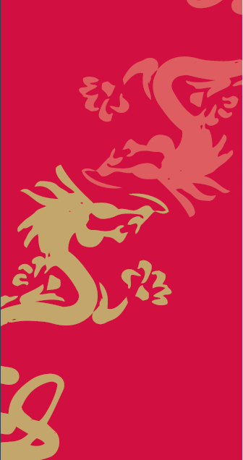
Confucius Institues in Wales Arts Competition 2019
Entry Form

Name:

School:

School Year:

Category entered (circle or delete as appropriate)
Photography
Art (Painting/drawing/calligraphy)
Poetry

Please provide a brief description of your submission explaining the inspiration behind it and how it meets the theme of ‘Celebrating friendship between Wales and China.’

(Younger pupils in Y3 and Y4 may leave this box blank if they wish)

Deadline for submission: Friday 25 October

