Application for Admission as a Postgraduate Student
We want to process your application as quickly as possible. It is therefore essential that all sections of the form are completed to ensure that your application can be processed efficiently. Please read the Guidance Notes to Applicants before completing the form in BLACK ink.
Please use CAPITAL letters.

Please provide your Staff ID number
(Please see Section 1.5 of the Guidance Notes)
1.5 If you are a member of staff at Cardiff University,please tick this box
1.4 Please state the month and year that you wish to start your sstudies
Please note that the majority of Taught programmes start in September each year. The University permits Research programmes to start on one of the following dates: 1 Oct; 1 Jan; 1 April; 1 July (subject to the approval of the School).
part-time?
full-time?
1.3 Do you wish to study
- Proposed Postgraduate Programme

  - In which School(s) do you wish to study?

  - Please indicate the programme for which you would like to apply
DNurs
EdD
EngD
DEdPsy
DSW
DHS
DClinPsy
Professional Doctorates
Subject, Research Area or Research Project Title
MScD (by Research)
MCh
MD
MPhil
PhD
Research
Other

Full Title of Taught Programme
PgCert
PgDip
MPH
MMus
MTh
LLM
MScEcon
MBA
MSc
MA
Taught

2. Personal Details (Please use CAPITAL letters)
2.1 Family Name: | First name(s)* :
Title (Mr/Mrs/Miss/Ms/Dr/Other) : | Former name:
Date of birth:
2.2 Are you applying with an Educational Advisor/Agent Y/N
Name of Agent:

2.3 Would you like to authorise anyone to act on your behalf
Name of Authorised Person:
Relationship to you: | Email Address:
2.4 Address
The home address will normally be used when we write to you. We will contact you by email, so please provide a current email address.
Home (Permanent) Address: | Correspondence Address (if different from Home Address:
Postcode/ Area code: | Postcode/ Area code:
Country: _ | Country: _
Email: | Email:
2.5 Applying for a Regulated Programme

If you are applying for a regulated programme, which would include teaching, health, social work and courses involving work with children or vulnerable adults, you must tell us about any criminal convictions, including spent sentences and cautions
(including verbal cautions) and bind-over orders.
If you are applying for a regulated programme, and you have a conviction, please enter X in the box ם
You only need to complete this question if you are applying for a regulated programme. If you are not sure, please contact admisisons@cardiff.ac.uk.

If you will require a visa for the programme you are now applying for, please ensure that you enter the country for the passport you will be using for your visa application as your first nationality.
The University will use your first nationality on your visa correspondence. Further information on Visas for UK Study is available on our website.

Passport/National Identity Card number Passport start date: DD/MM/YY Passport end date DD/MM/YY
Nationality and Visa Information Nationality and Passport Details
What is your country of permanent residence? Have you lived here since birth? Y/N
If no, when did you move to your country of permanent residence? DD/MM/YYYY Where were you born?
Please state your nationality as it appears on your passport
Dual Nationality (if applicable)
3.

3.1

3.2 Visa Information
Do you require an immigration visa to study in the UK? Y/N Have you previously studies in the UK? Y/N
If yes, Which Institution did you study at? Level of Study
There are time limits ('caps') on how long you can you study in the UK with a Tier 4 visa.
Before we issue your Confirmation of Acceptance for Studies (CAS), as a Tier 4 sponsor we will check that your proposed studies will not take you over the cap.
When assessing your visa application, the Home Office will also check that you will not exceed the cap, unless there are "compelling and compassionate circumstances", such as injury or disability.

English/Welsh Language Competency
All applicants must demonstrate that their language competence is at a level which will allow them to cope with the demands of their chosen programme.
Please choose one of the options available demonstrate your language competence. You will need to submit copies of certificate(s) as proof that you have obtained the necessary qualification.
My first language is English Welsh Another language Do you have any of the following language qualifications?

Qualification * | Pending/Awarded | Grade/score | Date of examination
GCSE /O Level
IELTS for UK study
IELTS (Academic)
TOEFL
Other English Language Test
Other
For further information on Cardiff University's English Language requirements go to our requirements page.
If you would like to improve your English before starting your course, or are required as a condition of your offer to attend a pre-sessional English course, please see our English Language Programmes.

Academic and Professional Qualifications
All applicants should send copies of academic and professional qualifications obtained, translated into English where appropriate.

Most Recent/Current Academic Qualifications
Please give details of your most recent/current undergraduate or postgraduate degree:

University/College | Degree/Qualification | Degree Subject | Date Degree Awarded/
(including full address and country in which studying) | (including grade) |  | Results Expected

Length of Course (years) Dates of Attendance From To

Mode of Study (tick as appropriate):

- Full-time
- Part-time
- Distance learning

Other Academic Qualifications Completed
Please list any other relevant academic qualifications obtained from the age of 16 onwards

University/College | Qualification | Date Obtained | Full-time, Part-time or
(including address and country) | (including grade) |  | Distance Learning

Professional Qualifications
Please provide details of professional or other qualifications received or pending

Name of Qualification | Date Achieved/To Be Taken | Method of Study  (part-time/full-time/ distance learning) | Name and Address of  Educational Institution/ Awarding Body

Professional Experience
You can provide details of recent professional experience which you feel is relevant to your application. This may be either current employment or previous employment experience.

Membership of Professional Bodies (if applicable)

Please state the name of the institution of which you are a member, your level of membership, the date you became a member, its expiry date (if applicable) and your registration number.

Personal Statement
Please provide information that is relevant to your application for admission such as:
- why you wish to follow this programme
- the benefits you expect to gain from it
- the skills and experience you possess which make you a suitable applicant

    - For Research Applicants Only
      - What is the title of you Research Proposal?

If you are putting forward your own research proposal, please attach your research proposal (maximum 3000 characters), and
let us know if you have made contact with a supervisor. If you are applying for an advertised project, or projects, you do not need to complete a research proposal. Please simply list the title(s) of the project(s) you wish to be considered for.
You will not need to complete multiple applications.

Funding:
Are you self funding your research?

Yes I will be self-funding my research □
No, I am not self funding my research □
Please provide the name of the funding you are applying for

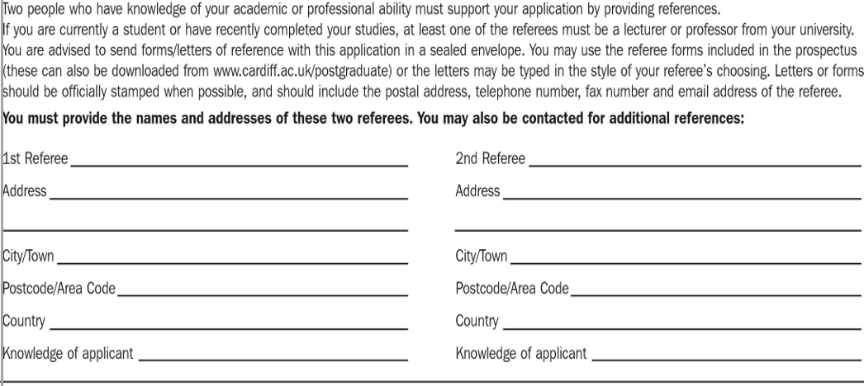
8. Confidential References

- Where did you learn about the postgraduate opportunities at Cardiff University?

How did you hear about the University?

  - Open Day
  - Google
  - Newspaper
  - Advertisment
  - Recruitment fair
  - Social Media
  - From an agent
  - Other

10. I confirm that, to the best of my knowledge, the information provided in this form is factually accurate and that no requested information, or any additional information relevant to this application, has been omitted.

Signature of Applicant Date
11. It is a condition of acceptance of a place to study at Cardiff University that you understand that in order to process your application it is necessary for personal information obtained in connection with our admissions process to be used and, where necessary, shared with UCAS or other relevant bodies. This is for the purpose of verifying your identity, qualifications and references so that your application to enter into a student contract with the University can be suitably assessed and considered. Where legitimate and necessary, the University may also share your data with UK agencies with duties relating to the prevention and detection of crime, apprehension and prosecution of offenders, collection of tax or duty, or safeguarding national security. Further information about how your personal data will be used, how long we keep it for and how we protect it whilst you are an applicant is available on our website at Data protection information for applicants.
I have read and agree with the following statement: (please tick box)
I consent to my information being shared in accordance with Cardiff University's Data Protection policy for the purpose of considering my application.

By submitting an application you are agreeing to abide by the rules and regulations of the University. If the University becomes aware that an applicant, prior to registering as a student, has failed to abide by these rules and regulations or has provided false or misleading information, an offer to study may be withdrawn.
It is the responsibility of applicants to provide full and accurate information in an application and to notify the University of any changes or corrections to the original application.
The University reserves the right to exclude an applicant who is considered on justifiable grounds to be unsuitable for a place on a particular programme according to individual circumstances.
The University reserves the right to reject or withdraw an offer based on an applicant's behaviour during any visit to the University (such as attending an interview, audition/workshop, offer holder visit day or a general visit to the University) if an applicant has displayed behaviour/s that are in contravention of the University's Equality and Diversity or Dignity at Work and Study policies (which all students and staff of the University are required to adhere to).

Checklist – please make sure that you include the following:
  - Application form
  - Two referee report forms/letters and contact details of both of them
  - Research proposal (Research students only)
  - Equality Monitoring Form*
  - Copies of relevant qualification certificates/transcripts
*please note that an Equality Monitoring Form must be submitted with your application

Completed forms and supporting documents should be sent to: Cardiff University, 30-36 Newport Road, Cardiff, CF24 0DE, UK Email: admissions@cardiff.ac.uk
Tel: +44 (0)29 2087 9999
Further information about the University is available at www.cardiff.ac.uk

