**Cardiff University**

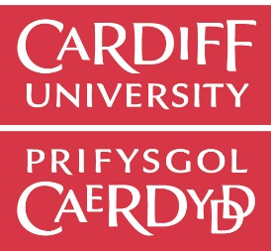**Graduation Publicity**

Local and national media seek out interesting stories regarding our new graduates. The University’s Communications and Marketing Team would be delighted to hear from any student willing to have contact with the media during graduation week. Some examples of stories covered during previous ceremonies include:

* Students who have excelled or have completed newsworthy research
* “Against the odds…” – eg overcame major hurdles to achieve degree
* Graduates about to embark on a new venture – eg high profile career start, round-the-world trip

These stories will enable the University to highlight your achievement as well as highlighting its contribution to your success. Your story may inspire others to follow in your footsteps, and will also help raise the profile of the academic discipline you pursued.

**PLEASE ONLY RETURN THIS FORM IF YOU HAVE A NEWSWORTHY STORY.**

**Graduate’s name:**

**Contact telephone number (**home / mobile**) and email address:**

**Degree:**

**School:**

**Date and time of graduation ceremony:**

**Home newspaper:**

**Newsworthy information (eg. Student achievements/interests etc):**

The information provided may be used by the public relations office to contact the media and possibly for use on the university’s website. It will not be used for any other purpose.

Please return to Cardiff University, Communications and Marketing Team, Deri House, 2-4 Park Grove, Cardiff, CF10 3PA.

Alternatively, contact Communications and Marketing on: +44 (0)29 2087 9074 or by email: [communications@cardiff.ac.uk](mailto:communications@cardiff.ac.uk)