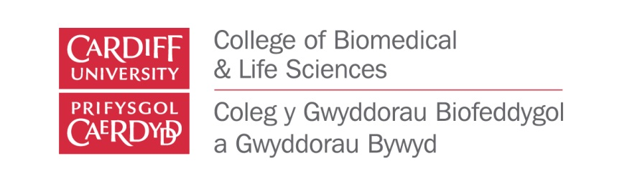

UK-INDIA Interdisciplinary Workshop on Advanced
Biomaterials and Biosensors

Outline programme (subject to change):
DAY 1 Presentations

9:00-10:30 | Session 1: Keynote = State of the art review of biomaterials for healthcare (biomaterials researcher)
10:30-11:00 | Coffee break
11:00-12:30 | Session 2: Keynote = Biomaterials: clinical need and future challenges/opportunities (clinical researcher)
12:30-13:30 | Lunch & posters
13:30-15:00 | Session 3: Keynote = Engineering smart biomaterials (materials engineer/mechanical bio-engineer)
15:00-15:30 | Coffee break
15:30-17:00 | Session 4: Keynote = Next generation imaging/readout/control systems (imaging expert/sensor technology expert)
19:00 | Dinner & networking

DAY 2 – Presentations

9:00-10:30 | Sessions 5: Keynote = The role of biologics in functionalising biomaterials (cell biologist/synthetic biologist)
10:30-11:00 | Coffee break
11:00-12:30 | Session 6: Keynote = The chemistry of bio-compatible materials for healthcare (chemical engineer)
12:30-13:30 | Lunch & posters
13:30-15:00 | Session 7: Keynote = Bio-fabrication and scale up (micro/nano-fabrication specialist/industrial scale up expert)
15:00-15:30 | Coffee break
15:30-17:00 | Session 8: Career mentoring (open forum Q&A)
19:00 | Dinner & networking

DAY 3 – Grant Applications

8:30-10:30 | Session 9: Small group grant application development
10:30-11:00 | Coffee break
11:00-12:30 | Session 10: Project pitching and audience feedback
12:30-13:30 | Lunch
13:30-14:30 | Session 11: Project refinement
14:30:15:30 | Session 12: UK/Indian funding opportunities
15:30-16:00 | Session 13: Wrap up & Next steps

