Safeguarding Children and Adults at Risk: Guidance Note 6

DBS Checks

Recruitment: requirement to carry out Disclosure and Barring Service (DBS) checks
The term “applicant” in this section applies to a person who is applying for a DBS check (could be staff, student or volunteer).

Good practice in recruitment applies to all paid and volunteer positions across the University. The University aims to take all reasonable steps to ensure that unsuitable people do not undertake positions with access to children and adults at risk. Each position will be assessed to determine if DBS check is required in relation to contact with children and adults at risk. DBS checks will be obtained for all roles where such checks are deemed necessary.

At first contact with the University all applicants are directed to the University Safeguarding Policy (Point 11) and code of conduct policies and guidance regarding our vetting procedures.

There are two barring lists maintained: one for working with children and a second for working with adults. The Safeguarding Vulnerable Groups Act 2006 defined “regulated activity” (see definitions above and listed professions below) with adults and children. Persons who are unsuitable for such work may be placed on one or both barring lists.

Advertising for positions specifically states if the role meets the definition of regulated activity. A barred person cannot undertake regulated activity and it is an offence for a barred person to seek to undertake it.

Overseas applicants or refugees/asylum seekers may be asked to provide other forms of identification and evidence of good character where it may not be practicable to rely on criminal record checks from within the UK.

All applicants are interviewed in person or where this is impractical, by Skype or similar technology.

All positions are offered subject to evidence of suitability. The University will make requests for references, to see evidence of appropriate qualifications for the post applied for, and require identity validation for e.g. right to work purposes, for each applicant.

Disclosure and Barring Service (DBS) checks will be sought for the successful applicant for every eligible position and must be in place before the applicant begins their employment, volunteering or course of study.

All applicants are advised that;
- failing to provide identity information to enable checks to be undertaken will prevent their application progressing,
- providing a false or altered DBS certificate or similar document from outside the UK will prevent their application progressing and may be reported to the police, DBS or other authorities as appropriate,
- failing to provide information regarding changes in their criminal status at any point during their employment may be reported to the police, DBS or other authorities as appropriate, may trigger misconduct procedures and possible dismissal.

If a DBS certificate includes an offence, it will not necessarily preclude the applicant from undertaking the role but a risk assessment will be undertaken against the specific post applied for.

Contractors’ staff working on University premises

It is the responsibility of the contractor as the employer of staff working on the University’s premises to ensure that each individual has been recruited appropriately to the role they are undertaking, and that DBS checks have been acquired for all appropriate roles in accordance with the eligibility criteria. In line with the University’s duty of care, Cardiff University will request confirmation from the employer that each worker requiring a DBS check has had a check at the appropriate level.

Any staff of a contractor whose roles give them contact with children or adults at risk in the course of their duties for the University will abide by the safeguarding and practice policies of the University, and may be required to attend appropriate training.

Disclosure and Barring Service (DBS) information

Any applicant who believes the content of their DBS certificate to be inaccurate should contact the DBS as soon as possible.

Applicants will be reminded that filtering rules apply to all DBS checks. Certain minor and “one-off” offences will be filtered (not displayed) as content on a DBS check. An applicant does not have to reveal offences that are/have been filtered at any point during the recruitment process.

Where an applicant is subscribed to the DBS Update Service, they will be asked to present their certificate and ID to the named member of staff. Each applicant will be asked to explicitly consent to the University running a status check on their DBS certificate. The Update Service is particularly recommended to students embarking on professions eligible for DBS checks as a practical asset to their employment opportunities.

NB: Students on work placements are not deemed to be volunteers by the DBS and therefore there is a cost levied by the DBS (in addition to administration costs) for their DBS checks and for personal subscription to the Update Service.

It is an offence for any person placed on a DBS barring list to seek to undertake regulated activity with the vulnerable group (adult, child or both) from whom they are barred. The University will report any applicant committing such an offence to the DBS and the appropriate police authority.

Individuals who are placed in regulated activity are subject to the DBS duty to refer which falls to the employing/deploying person to refer to the DBS any person in regulated activity whose actions or lack of action have harmed, cause harm towards, or posed a threat of harm, to a person in their care. This referral allows the DBS to consider whether the individual should be barred from undertaking regulated activity in the future. All such referrals will be logged (see referral log guidance).
https://www.gov.uk/government/publications/dbs-referrals-form-and-guidance
The University will inform an individual directly if this referral is to take place. The DBS will correspond with the individual throughout the process which may include an opportunity to make representation to the DBS regarding their case. The University is aware that all material sent to the DBS to inform a referral may be shared with the referred person during the barring process.

DBS requirements - Student applicants
Many students who plan to undertake certain fields of study in preparation for careers in contact with children and adults at risk may require a DBS check before beginning their studies. Many positions in careers in health, childcare, social care, social work, education and youth work will be in regulated activity and require an enhanced DBS with a check against the appropriate barring list(s).
See link for further detail: https://www.gov.uk/government/uploads/system/uploads/attachment_data/file/519060/Guide_to_eligibility_v8.1.pdf

All such students will be provided with the guidance to complete a DBS application form online as soon as they are accepted onto the course.

Failure to submit a DBS application on time may prevent the student taking up their place at the start of term.

The DBS certificate remains the property of the applicant but it must be shown to a member of the Admissions team who will log the details.

Any issues of concern arising from the content of a DBS certificate will be discussed directly with the applicant. Content may indicate that the applicant is unsuitable for the position or future career of their choice. The University will endeavour to support students with guidance on alternative careers should the content of their DBS certificate prevent them from following their choice of study. The University is obliged to refuse admission if the DBS disclosure, on a reasonable assessment, would disqualify the applicant from practising as a professional in the context of the activities of the University. Regulated activity is defined by the Safeguarding Vulnerable Groups Act 2006 as amended by the Protection of Freedoms Act 2012 (‘Professions and positions eligible for DBS checks’).

Disclosure and Barring Service (DBS) Check Procedures

The Human Resources Pre-Employment Checks Policy is also relevant.
The DBS procedures safeguard children and vulnerable adults by providing access to criminal record information. These procedures relate to staff (including casual staff) and volunteers only.

- Types of checks
The table sets out the types of check that can be undertaken.

Type of Check | Who check applies to | Information checked
Enhanced Check with DBS barred list check (Children) | - Someone undertaking regulated activity in relation to children;  - post is exempt from the Rehabilitation of Offenders Act 1974 and listed in the Police Act 1997 (Criminal Records) Regulations 2002. | - Police national computer  - Police information  - Children’s barred list
Enhanced Check with DBS barred list check (Adults) | - Someone undertaking regulated activity in relation to adults;  - post is exempt from the Rehabilitation of Offenders Act 1974 and listed in the Police Act 1997 (Criminal Records) Regulations 2002. | - Police national computer  - Police information  - Adult’s barred list
Enhanced Check with DBS barred list check (Children and Adults) | - Someone undertaking regulated activity in relation to both children and adults as above  - post is exempt from the Rehabilitation of Offenders Act 1974 and listed in the Police Act 1997 (Criminal Records) Regulations 2002. | - Police national computer  - Police information  - Children’s and Adult’s barred list
Enhanced Check | - Used when someone meets the pre September 2012 definition of regulated activity.  - Available for recruitment into posts that are exempt from the Rehabilitation of Offenders Act 1974 and that are listed in the Police Act 1997(Criminal Records Regulations) 2002 | - Police national computer  - Police information
Standard Check | - Primarily for people entering certain professions such as : members of the legal and accountancy professions which are exempt from the Rehabilitation of Offenders Act 1974 | - Police national computer; the DBS certificate issued will include information on both spent and unspent convictions, as well as details of reprimands, cautions and final warnings that have not been filtered.

A series of flow diagrams is shown in the appendices to enable managers to establish which, if any, level of check is required.

Regulated Activity is defined in Appendix 1 to the Policy.

The following should be noted:

- Basic checks (which contain details of unspent convictions or cautions) can be carried out for roles that are covered by the Rehabilitation of Offenders Act (ROA). Cardiff University requires individuals who are undertaking roles that are covered by the ROA to complete a Declaration of Criminal Record (DCR). Roles which have access to enhanced rights to sensitive or confidential information will be subject to the Government Baseline Personnel Security Standard (BPSS). A basic criminal record disclosure (confirming the details of any unspent convictions by applying for a basic disclosure certificate from Disclosure Scotland) will be conducted for posts covered by the BPSS.

- It is a criminal offence for an employer to obtain a DBS check for a role that is not exempt from the Rehabilitation of Offenders Act (ROA). Employers that do so are not only in breach of Part V of the Police Act 1997, but also the ROA and the Data Protection Act, which requires that data be processed fairly and lawfully. An applicant or an existing employee may seek legal recourse in a civil court, against the university should it request an unlawful check.

2. Staff Responsibilities

2.1 Designated members of the HR Service Centre and who are approved by the DBS as counter- signatories are responsible for the operation of the disclosure process as it applies to staff recruitment.

2.2 Lead Counter-signatory
The Lead Counter-signatory is:
- accountable for compliance with the DBS Code of Practice and this procedure;
- responsible for the approval of counter-signatories;
- responsible, in conjunction with the relevant HR Manager, for referring individuals to the DBS for consideration of barring in relevant circumstances .
The Head of HR Operations will be Lead Counter-signatory.

2.3 Counter-signatories
Team Leaders, HR Service Centre, are Counter-signatories and are responsible for:
- checking and validating the information provided by the applicant on the application form;
- countersigning Disclosure application forms to confirm that the position is covered by the Exceptions Order to the Rehabilitation of Offenders Act 1974 and that therefore, the organisation has an entitlement to access criminal record information and that any disclosures requested are at the appropriate level;
- maintaining accurate records of Disclosures applied for and received;
- controlling the use of, access to and security of Disclosures;
- advising on DBS-related issues;
- complying with this policy and the DBS Code of Practice.
2.4 Line managers are responsible for determining which posts should be subject to a DBS check and the level of check required with reference to the definitions of ‘regulated activity’ below.

3. Research
3.1 Research Passport Scheme
Where a Disclosure is required, it is the University’s responsibility as the substantive employer to confirm that a check has been obtained, or arrange for one to be obtained. The University, in conjunction with the NHS organisation, is responsible for determining whether a Disclosure will be required.

3.2 Research involving children and vulnerable adults
When submitting a research proposal, the author is required to identify work which would require a Disclosure due to the nature of the research. If a Disclosure check is required, the planned research must not take place until this has been completed.

4. Recruitment to posts requiring a DBS check

4.1 The line manager of the post is responsible for determining which posts require a DBS check. This must be done before any activity commences and at the commencement of the recruitment process for a vacant post. The flow diagrams shown in the appendices provide guidance on the factors which must be considered in this assessment. The following are examples of posts that undertake regulated activity and therefore, require the relevant barred list to be checked:
- All roles within the Daycare Centre
- Academic roles that include clinical duties
- Occupational Health Nurse
4.2 Managers are responsible for the ongoing assessment of the role to ensure that the level of check is appropriate and for the initiation of a different level and/or type of check in the appropriate circumstances.
4.3 DBS checks which individuals may have from previous employers, are accepted as proof of satisfactory clearance when:
- the disclosure is at the correct level i.e. Standard / Enhanced / Enhanced + Barred list
- free from any offences that would prevent them being employed by Cardiff University
- and the individual has subscribed to the update service, which states that there is no change to the certificate
5. Validity and frequency of checks

5.1 A DBS check is only up to date at the point at which it is issued. Therefore, contracts of employment issued to those individuals in roles which are subject to a DBS check will contain a clause which states that if an individual is subsequently cautioned, charged, summonsed or convicted of a criminal offence, then they must inform their line manager immediately. The line manager will consider the effect of the offence on the employee’s post. The manager may need to discuss the implications with their local HR Manager/Business Partner. Failure by an employee to disclose information may lead to disciplinary action.

5.2 Should an individual who has previously undertaken a DBS check move to another post in the University which would also be subject to such a check, the existing DBS disclosure will be acceptable providing the following apply:
- The type and level of Disclosure Check must be unchanged
- The new work does not represent a significant increase in responsibility for, and contact with, children and/or adults
- The individual is registered with the online update service and, following a check of the update service, the certificate has been verified as current and valid.

6. Applying for a DBS check
6.1 Following interview, the successful candidate will be advised that any offer of employment is subject to the University receiving a satisfactory DBS check at the appropriate level. It will not normally be possible to commence employment with the University or take up a new position or work until the DBS check process is complete.

6.2 The relevant DBS documents will be sent to the candidate with the conditional offer of employment and an appointment will be made with HR Service Centre to complete and verify information.

6.3 Only in exceptional circumstances can an individual commence work without the full results of the Disclosure being known and this can only be authorised by a College Registrar (or nominated deputy) or Head of HR Operations (or nominated deputy). Prior to such authority being sought, the following must have been undertaken:
- satisfactory employment references must have been received
- the line manager must have undertaken a risk assessment to determine and ensure that sufficient safeguards are in place to ensure the individual has no unsupervised access to children or adults.
6.4 As a Registered Body, the University must establish the true identity of the applicant, through the examination of a range of original documents as set out by the DBS (Disclosure and Barring Service - GOV.UK)

7. Receipt of DBS Disclosure
7.1 Once the check is completed, the DBS will send a certificate listing results to the applicant. The HR Service Centre will ask the applicant for sight of the DBS Certificate.

7.2 DBS certificate information will be handled in accordance with the University’s Records Management Policy.

7.3 In accordance with the Rehabilitation of Offenders Act, a criminal conviction may not automatically prevent an individual from working for the university.

7.4 Should the Disclosure reveal details that may be of concern, it is the responsibility of the Head of School/Department to consider the suitability of the candidate to commence / continue employment. The Head of School/Department, with advice from their College/Professional Services HR Manager, will undertake a risk assessment to determine whether the risk of employing or continuing to employ an individual can be taken and what safeguards would need to be introduced to manage that risk. In accordance with the Rehabilitation of Offenders Act 1974, a criminal conviction may not automatically prevent an individual from working for the university. Factors that must be considered include:

- the requirements of the role and the level of supervision the individual will receive;
- the seriousness of the offence/issue raised and its relevance to the safety of employees, service users, clients or property;
- how relevant the offence is in relation to the role to be undertaken;
- how much time has elapsed since the offence was committed and whether it was a one-off incident or part of a history of offending;
- whether the individual was open and transparent about their past and declared their criminal background prior to receiving the DBS Disclosure.
A copy of the risk assessment will be forwarded to the HR Service Centre for retention on the individual’s personal file.

8. Overseas applicants and UK applicants who lived abroad
8.1 Individuals who have never lived in the United Kingdom, or UK citizens who have spent a considerable amount of time living abroad in the last 5 years, will need to provide a 'Police Certificate of Good Conduct' or a CRB / DBS Disclosure from that country. Reference should be made to the Guidance Information. It may also be possible to obtain such a check through the relevant embassy in the UK.

8.2 Where an individual has been resident in the UK for at least two months, a DBS check should be obtained in addition to confirmation of their criminal record overseas.

9. DBS Disclosures for agency workers, contractors, subcontractors
Those responsible for hiring agency workers, contractors, sub-contractors and volunteers must ensure that the requirement for such individuals to have competed appropriate levels of DBS checks (and that such certificates are satisfactory) forms part of any contractual agreement.

10. Referring individuals to the DBS
Where an employee who works in regulated activity with children or other vulnerable groups is dismissed or removed from working with children or other vulnerable groups due to concerns about harm or risk of harm to such groups, a referral must be made to DBS. This will be conducted by the Lead Counter-signatory for the university.

11. Further information, advice or support
This is available from:
- your local College/Professional Services HR Team or HR Service Centre.
- DBS customer services on 03000 200 190 or email customerservices@dbs.gsi.gov.uk
- Nacro’s Employer Advice Service on 0845 600 3194 or employeradvice@nacro.org.uk or visit the Nacro website

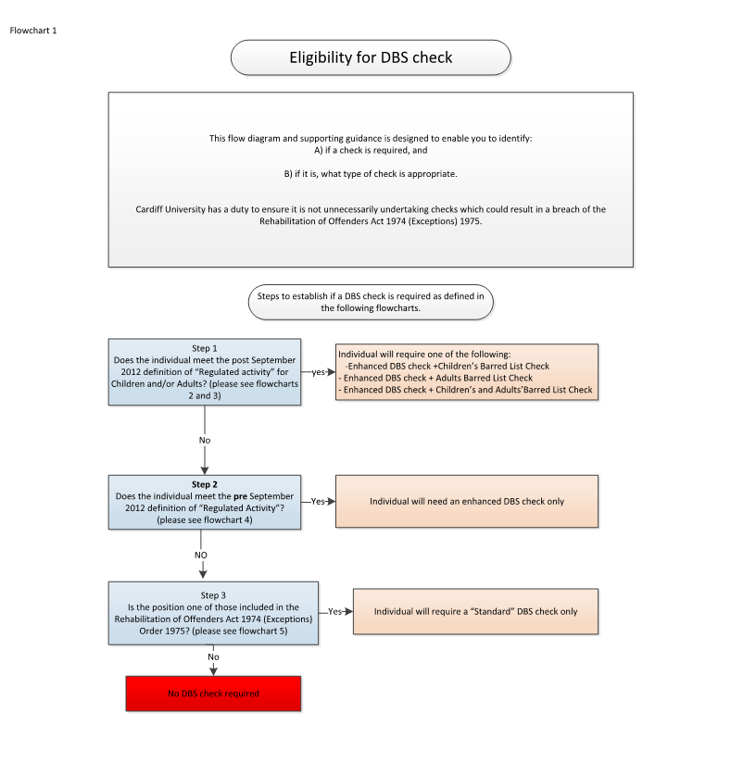
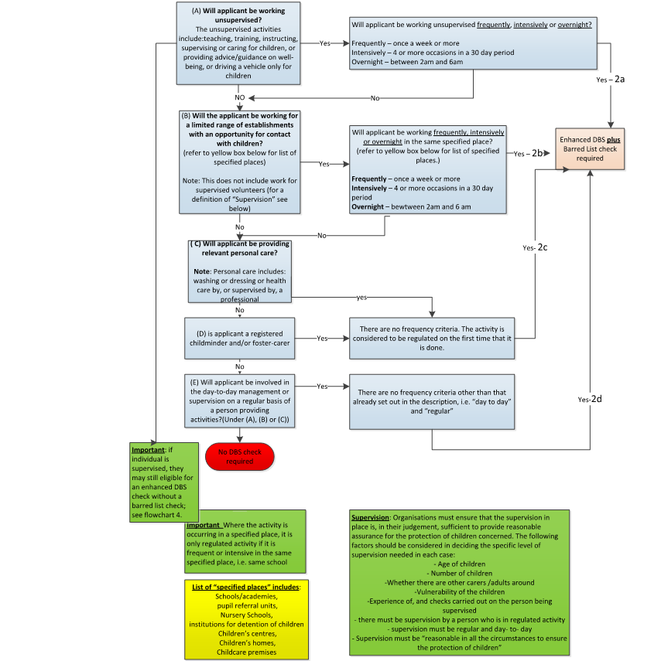
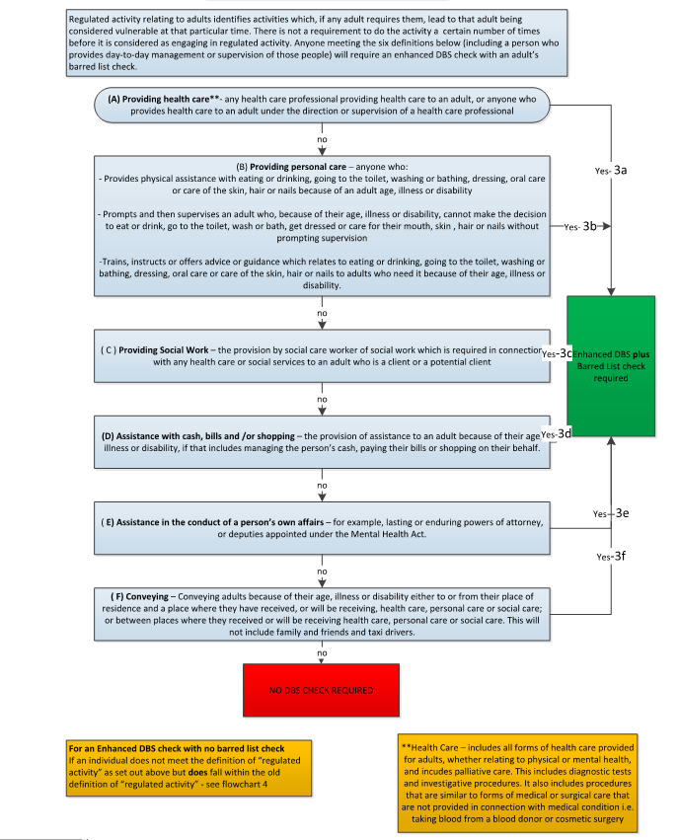

Under the changes that were introduced as part of the Protection of Freedoms Act 2012, the definition of Regulated Activity was changed with a view to reducing the number of Barred List checks that employers would request. Under guidance provided at the time, it was anticipated that there would be a reduction in requests for Barred List checks, from 9 million to 5 million per year. The guidance also confirmed that any role that was previously eligible for an Enhanced level Disclosure would remain eligible for an Enhanced level check, but only those meeting the new definition of Regulated Activity could have a Barred List check.
From 29 May 2013, the DBS has removed certain specified old and minor offences from criminal record certificates issued from this date. The filtering rules and the list of offences that will never be filtered can be accessed via: DBS filtering guidance - GOV.UK
Further information can be found on the following websites DBS guide to eligibility - Publications - GOV.UK Criminal record checks: guidance for employers - Detailed guidance - GOV.UK
DBS code of practice - Publications - GOV.UK
Further information is available via the following link: DBS referral guides - Publications - GOV.UK
Cardiff University is responsible for conducting DBS checks for Clinical Academics who hold honorary contracts with the NHS.

